Excerpt taken from Alli’s original email on Cold Stowage. Answers in green.
There is another form that I have to fill out regarding Cold Stow/Special Orientation:
Please answer the following for me so that I can fill out that form:

What temperature do you need? Refrigerator temp? Frozen? What degree?
Refrigerator temperature should be fine for cold storage. Definitely not frozen. Something between 4 and 9 degrees Celsius would keep the yeast cells dormant.
Does it need to be cold right at hand over, stay cold during launch? YES
Can it be destowed cold, and then plugged in right away? Wait time? YES, no wait time is needed to plug in.
What about after experiment is complete? Does it need to be cold until its return on Space X 5 (a month later)? Once the ardulab is unplugged, it needs to be placed back into cold stowage between 4 and 9 degrees Celsius and continue in cold stowage on return flight Space X 5.
Does the experiment need to be set by an agent? NO
Are there any special orientation requests during launch? YES. The ardulab will need to placed into storage for flight with the Y-plate on the bottom of the ardulab.
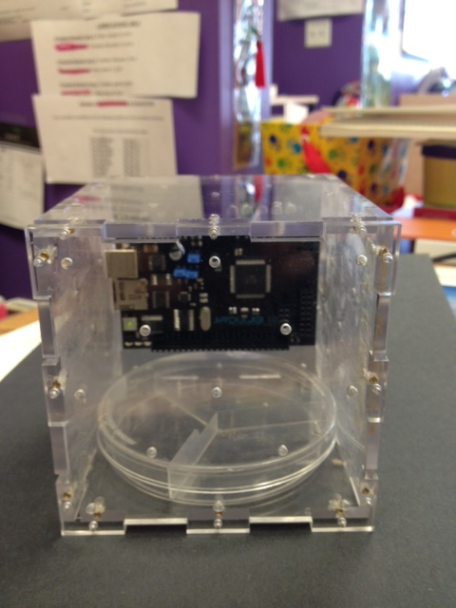
What is the temperature for loss of science? 0 degrees Celsius will freeze and can break down structures in the cell. They will also start dying around 58 degrees Celsius, but I don’t see that being an issue in transit/stowage or flight.
Minimum temp allowed? Max temp allowed? 1 degree Celsius min and 57 degrees Celsius max
Approximate weight of your total experiment? 700 grams
Shelf life for the samples being launched? As long as the ardulab is kept in cold stowage, the yeast should remain dormant until removed and placed into room temperature on board the ISS. After growth, once placed back into the cold stowage, the yeast cells will become dormant/inactive. Approximately three months would be reasonable.

I appreciate your time. This will ensure that we get all of the things we need for the experiment, and that NASA has no issues with any of the experiments that are flying. Please call me on my cell at 832-876-5724 should you have any questions.

