The Effects of Microgravity and Light Wavelength on plant growth in an Ardulab

Experiment Design 1
Our first step would be to obtain materials. The second step is to divide the ArduLab into two parts. The divider should be opaque. Next we will place the plant gel (Polyacrylamide Copolymer), which retains more than 400x its weight in water, and because of this we do not need to water it more than once a month. The plant gel will be in a container, possibly made out of Gore-tex. The container will have some sort of covering over the gel so that the plants can grow through it, such as gauze or nylon hose. We will place eight seeds per side into the gel and add water (the order of adding seeds and water may change). Our fourth step would be to program the lights. We plan for 14 hours of light and 10 hours of darkness, one side will have 80% blue LEDs and 20% red LEDs, and the other will have 80% red and 20% blue. The fifth step is to obtain 2 cameras, one for each side that would take one photograph shortly after the light cycle begins, a second at the seventh hour and one at the fourteenth hour just before the cycle ends. The camera will be angled so that in the photo you would be able to see the grid. The grid would be attached to all sides in millimeter increments this will allow us to measure the growth. The next step will be to place a string across the top of the ArduLab because of thigmotropism and it could also be used as a reference system for estimating plant growth. The plant gel is clear so we will also be able to observe root growth. Also if a backup water system is necessary an iv bag with springs to squeeze the water into the plant gel may be included. We will know if watering is necessary if the volume of the plant gel is greatly reduced.
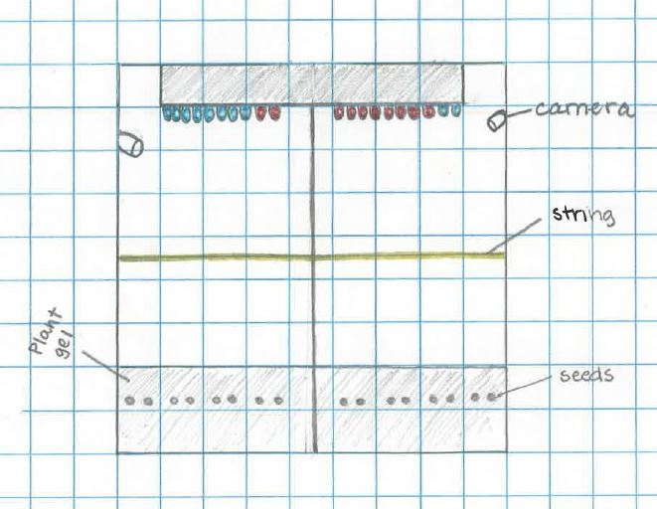

Experiment design 2

First, we need to divide our ArduLab. The divider should be a mirror like material on both sides. We will place a camera on each side of the ArduLab. We’re going to place the same number of red and blue LEDs on each side, but on one side the red will be at 100% intensity and the blue will only be 40% intensity and the other side will be blue 100% intensity and red 40% intensity. The lights will stay on for 14 hours and be turned off for 10 hours. We will have 2 centimeters of rock wool. We will place 4-6 seeds evenly in the rock wool on each side. We will saturate the rock wool just prior to launch. We will also have a backup watering system. The watering system will consist of a double layered water bag. The rock wool will be contained of nylon hose, and suspended towards the middle of the ArduLab. The watering system will consist of a moisture sensor attached to the water bag that would open the valve for 10 seconds and allow the water to pass into the rock wool by diffusion. There will be tubes leading from the bag into the rock wool, and the bag will need to be squeezed when the valve is open. A grid system of millimeter increments will be placed on the insides of every wall of the ArduLab. The cameras will take a photograph when the lights first turn on, and at the 7th hour and just before the lights are turned off at the 14th hour, and this will repeat daily.
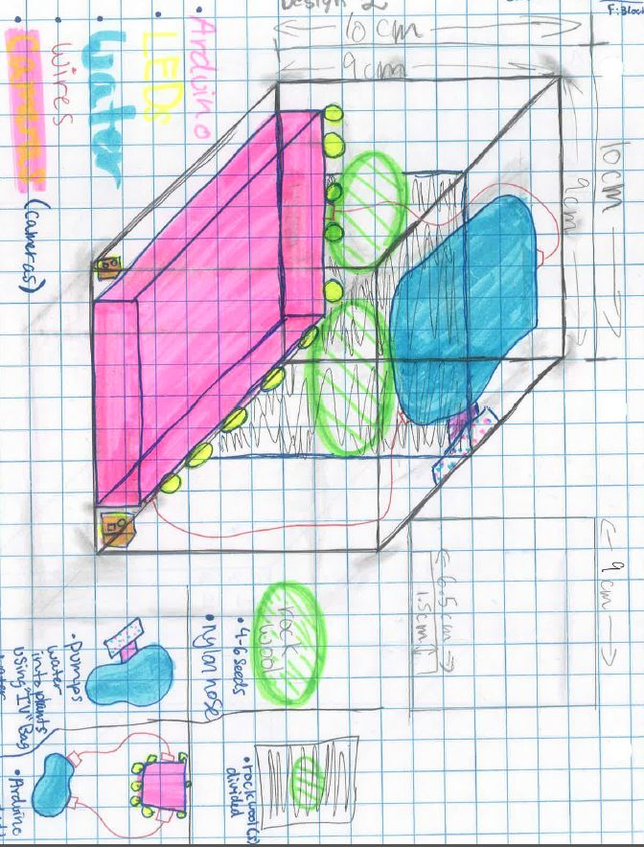

Experimental Design 3

We will divide the Ardulab in half with an opaque material, and use a grid measuring system to measure the plant growth. We will place three or four seeds evenly spaced on each side of the Ardulab. The seeds will be placed within several layers of cheesecloth that will be saturated just before launch. There will be a thin layer of Gor-Tex surrounding the cheesecloth and pipette. We are going to have two cameras per side in order to attempt to record growth from different angles. We will take pictures three times- just after the lights turn on, at the seven hour mark, and just before the lights turn off at fourteen hours. There will be an equal numbers of red and blue LED lights on each side; however, on one side, after seven hours the red lights will turn off, and on the other side the blue lights will turn off. The watering system will consist of a pipette similar to an eyedropper placed underneath the cheesecloth. The bulb will be squeezed every five days and release 1/6 the amount of the water contained in the dropper. The growth will be measured by comparing the plant to a grid measuring system.
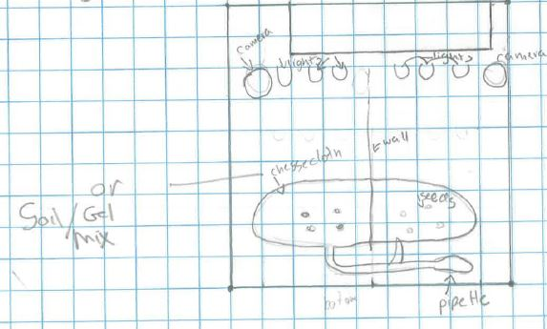

Experimental Design 3B

The general idea of experimental design 3B is relatively the same as experimental design 3. The only difference would be the material that the plant seeds are placed in. Instead of cheesecloth, we would make a mixture of 80% plant gel and 20% soil, so that not only would the plant be watered for a longer period of time with the plant gel, but it would also receive essential nutrients for the plant’s growth that it would normally receive on Earth. The Ardulab would also be divided into two sections, with an opaque material in between them. One side would receive 7 hours of red LED light and a combination of red and blue LED lights for 7 hours, making the overall period of light exposure 14 hours. On the opposite side of the Ardulab, the plant would receive 7 hours of blue LED light and a combination of red and blue lights for 7 hours. There will also be two cameras, one on each side. They will both take pictures at the end of the 7 hour individual light period and at the end of the combination light period. There would be a small water supply contained in an IV bag and surrounded by two layers of Gore-Tex underneath the plants (creating the three-layer containment). There would be tubes connecting from the IV bag into the plant gel. The water would be measured every day and when the plant is in need of water, the springs would push against the sides of the tube and release the water into the gel. The gel, however, would also be pre-watered, so that there would be less water used in the experiment once is space. As to the number of seeds, there would be approximately 3-4 seeds on each side. The gel would also be surrounded by nylon hose so that the plants could grow, but the gel would be contained. To measure the plant, we would place a graph on the side of each division of the Ardulab that would be separated in millimeter increments. The cameras would be placed in the corner of each side to capture the most footage, and the gel would be clear so that the camera would have an easy view of the plant’s roots as well.

