Document Guidelines
- Please make every attempt to write text in present tense where applicable.
- [IDRD] indicates the field is required for the Increment Definition and Requirements Document Annex 5: Payload Tactical Plan, Table 3.0.
- Please note: After Baseline, a CEF must be submitted in order to change an [IDRD] field.
- [nasa.gov] indicates the field appears on the website http://www.nasa.gov/iss-science/.
- To check a box: double click > default value = checked > ok.
- Submit completed form to the RPWG.

Investigation/Research Common Data
(Required for All Investigations)

Investigation Name [IDRD] [nasa.gov]: NanoRacks – Duchesne Light wavelengths on Algae production

Investigation Title [nasa.gov]: NanoRacks – Duchesne – Algae production in microgravity with variable wavelengths of light
OpNom [nasa.gov]: NanoRacks Module-

Principal Investigator: If there are additional Principal Investigators, please copy, paste, and fill in for each Principal Investigator.
- First Name [nasa.gov]: Susan
- Last Name [nasa.gov]: Knizner
- Email: susan.knizner@duchesne.org
- Phone [(###) ###-####]: 713-468-8211
- Mailing Address: 10202 Memorial Drive, Houston, Tx 77024
- Credentials (M.D., Ph.D., M.S., etc.) [nasa.gov]: M. in Curriculum and Instruction
- Institution [nasa.gov]: Duchesne Academy of the Sacred Heart
- Investigator Location [nasa.gov]: TX, USA
- Institution Type:

Academia
Government
Industry
Military
Nonprofit
Space Agency

Co-Investigator/Collaborator: If there are additional Co-Investigators/Collaborators, please copy, paste, and fill in for each Co-Investigator/Collaborator.
- First Name [nasa.gov]:
- Last Name [nasa.gov]:
- Email:
- Phone [(###) ###-####]:
- Mailing Address:
- Credentials (M.D., Ph.D., M.S., etc.) [nasa.gov]:
- Institution [nasa.gov]:
- Investigator Location [nasa.gov]:
- Institution Type:

Academia
Government
Industry
Military
Nonprofit
Space Agency

Person publically credited as source of this | Susan Knizner
information: | First Name Last Name

Contact:
- Primary Contact responsible for scientific content of this form:
  - First Name: Susan
  - Last Name: Knizner
  - Email: susan.knizner@duchesne.org
  - Phone [(###) ###-####]: 713-468-8211

- Secondary Contact:
  - First Name:
  - Last Name:
  - Email:
  - Phone [(###) ###-####]:

Developer(s) [nasa.gov]: NanoRacks LLC, Houston, TX 77058, USA.

Sponsoring Space Agency [IDRD] [nasa.gov]: Space agency responsible for the implementation of the investigation.
Canadian Space Agency (CSA)
European Space Agency (ESA)
Japan Aerospace Exploration Agency (JAXA)
National Aeronautics and Space Administration (NASA)
Roscosmos

Sponsoring Organization [nasa.gov]: NASA Investigations Only - Official name of the NASA organization responsible for sponsoring the research for flight.
Human Exploration and Operations Mission Directorate (HEOMD)
Italian Space Agency (ASI)
NASA Education (EDU)
National Laboratory (NL)
National Laboratory - Department of Defense (NL-DoD)
National Laboratory - Department of Energy (NL-DOE)
National Laboratory - National Institute of Standards and Technology (NL-NIST)
National Laboratory - National Institutes of Health (NL-NIH)
National Laboratory - National Science Foundation (NL-NSF)
National Laboratory - U.S. Agency for International Development (NL-USAID)
National Laboratory - U.S. Department of Agriculture (NL-USDA)
National Laboratory Education (NLE)
Science Mission Directorate (SMD)
Technology Demonstration Office (TDO)

Research Benefits [nasa.gov]: Does the research have potential benefits in the following areas? (Choose all that apply.)
Earth Benefits
Scientific Discovery
Space Exploration

Increment(s) [IDRD] [nasa.gov]: Inc 39/40

Number of Investigations: (Increment Specific) One.

PAO Summary (“Research Objectives” in IDRD) [IDRD] [nasa.gov]: Different wavelengths of light in the visible spectrum cause different effects on algae. The purpose of this experiment is to determine the effect of different colored lights on algae (chlorella vulgaris). If algae are exposed to different visible colors of light, then the photosynthesis rate will change in microgravity. This will determine which color of light is preferred. Different wavelengths of light in the visible spectrum cause different effects on the growth of algae in microgravity.
Research Overview [nasa.gov]: Bulleted list slightly more detailed than the PAO summary, written on the 4th grade level. The Research Overview should highlight why the research is needed, what the research accomplishes, and what the impact of the research is. Information is used in the Research and Planning Working Group (RPWG) Planning process and Crew Briefings.
- This experiment uses a standard 1.0 U (10 cm x 10 cm x 10 cm) ArduLab in a NanoRacks Module containing algae in petri dishes of Phytoblend agar as the growth media and (4 red and 4 blue) LED lights with 2 cameras.

- The payload is automated; it will utilize the standard NanoRacks Platform plug-n-play operations for power and data.

- NASA has used white, green, and red lights in the past; this is one of the reasons we have decided on these colors. Red LED lights have been proven by NASA to cause the plants to have a “higher concentration of anthocyanin, an antioxidant that can combat some of the effects of cosmic radiation” (LED Lights Used in Plant Growth Experiments for Deep Space Missions). Another NASA study concluded that green lights are also beneficial to plants.

- In 2011, experiments were done by Chambers; they found a trend of the best colors to grow algae. The three colors that provided the most growth are blue, green and red light. If we can test for the effect of light wavelengths on the growth of algae, then we can find the optimal color for the highest overall rate of algae growth.

- NanoRacks-Valley Christian High School-Plant Growth (NanoRacks-VCHS-Plant Growth) is a NanoLab project studying the growth and growth rate of Wisconsin Fast Plant and English Thyme seeds in microgravity.

- Billings Central Catholic High School students(2013) have designed and built an experiment to test how well algae grows — and how much carbon dioxide it consumes — in a zero-gravity environment. This experiment was through the HUNCH Program.

- THE EFFECTS OF LIGHT INTENSITY ON THE GROWTH RATES OF GREEN ALGAE 12,'3CONSTANTINE SOROKIN 4 AND ROBERT W. KRAUSS DEPARTMENT OF
BOTANY-. UNIVERSITY OF MARYLAND, COLLEGE PARK, MARYLAND.

- http://www.docstoc.com/docs/22054985/Growing-Lipid-Rich-Microalgae-in-Wastewater-for-Biodiesel-Production
- https://www.youtube.com/watch?v=c7Goyg12Reg
- http://www.ncbi.nlm.nih.gov/pmc/articles/PMC541035/

Space Applications [nasa.gov]: Algae have a very high percentage of oil. Algae could be used as an energy source for the ISS.
Earth Applications [nasa.gov]: Algae could be used as a fuel source for cars.

Category [IDRD] [nasa.gov]: The investigation is classified within one research category.
Subcategory [nasa.gov]: The investigation is classified within one research subcategory.

 | Biology and Biotechnology
 |  | Animal Biology – Invertebrates | Microbiology
 |  | Animal Biology – Vertebrates | Microencapsulation
 |  | Cellular Biology | Plant Biology
 |  | Macromolecular Crystal Growth | Vaccine Development

 | Earth and Space Science
 |  | Astrobiology | Earth Remote Sensing
 |  | Astrophysics | Heliophysics

 | Educational Activities and Outreach
 |  | Classroom Versions of ISS Investigations | Educational Demonstrations
 |  | Commercial Demonstrations | Engineering Education
 |  | Cultural Activities | Student-Developed Investigations
 |  | Educational Competitions

 | Human Research
 |  | Bone and Muscle Physiology | Human Microbiome
 |  | Cardiovascular and Respiratory Systems | Immune System
 |  | Crew Healthcare Systems | Integrated Physiology and Nutrition
 |  | Dental Health | Nervous and Vestibular Systems
 |  | Habitability and Human Factors | Radiation Impacts on Humans
 |  | Human Behavior and Performance | Vision

 | Physical Science
 |  | Combustion Science | Fundamental Physics
 |  | Complex Fluids | Materials Science
 |  | Fluid Physics

TBD: To Be Defined Based on Selected Science Objectives

 | Technology Development and Demonstration
 |  | Air, Water and Surface Monitoring | Power Generation/Distribution Systems
 |  | Avionics and Software | Propulsion Systems
 |  | Characterizing Experiment Hardware | Radiation Measurements and Shielding
 |  | Communications and Navigation | Repair and Fabrication Technologies
 |  | EVA Systems | Robotics
 |  | Fire Suppression and Detection | Small Satellites and Control Technologies
 |  | Food and Clothing Systems | Space Structures
 |  | Imaging Technology | Spacecraft and Orbital Environments
 |  | Life Support Systems and Habitation | Spacecraft Materials
 |  | Microbial Populations in Spacecraft | Thermal Management Systems
 |  | Microgravity Environment Measurement

Hardware Description [IDRD]: (Increment Specific) NanoRacks Module-41 P/N NRP-10041, S/N 1001: a 10 x 10 x 10 cm module for standard power/data interface with the NanoRacks Platform for USB power and data transfer. Utilizes a ArduLab structure and electronic interface.

Unique Payload Constraints [IDRD]: (Increment Specific) The experiment needs plugged into the NanoRacks Platform and powered-up for 30 days of operations (+/- week) before return.

Imagery [nasa.gov]: Submit images, drawings, and graphical data separately in a high resolution (1MB or larger) .jpg format with the completed Investigation Summary Form. Image caption should have a detailed description of the image contents, activity occurring in the image, a NASA number if available, names of the individuals in the image, and image credit information. The primary image is used for communication projects. Images of the investigation on the ISS will be added following operation.
Primary Image Caption: Additional Image Caption 1:
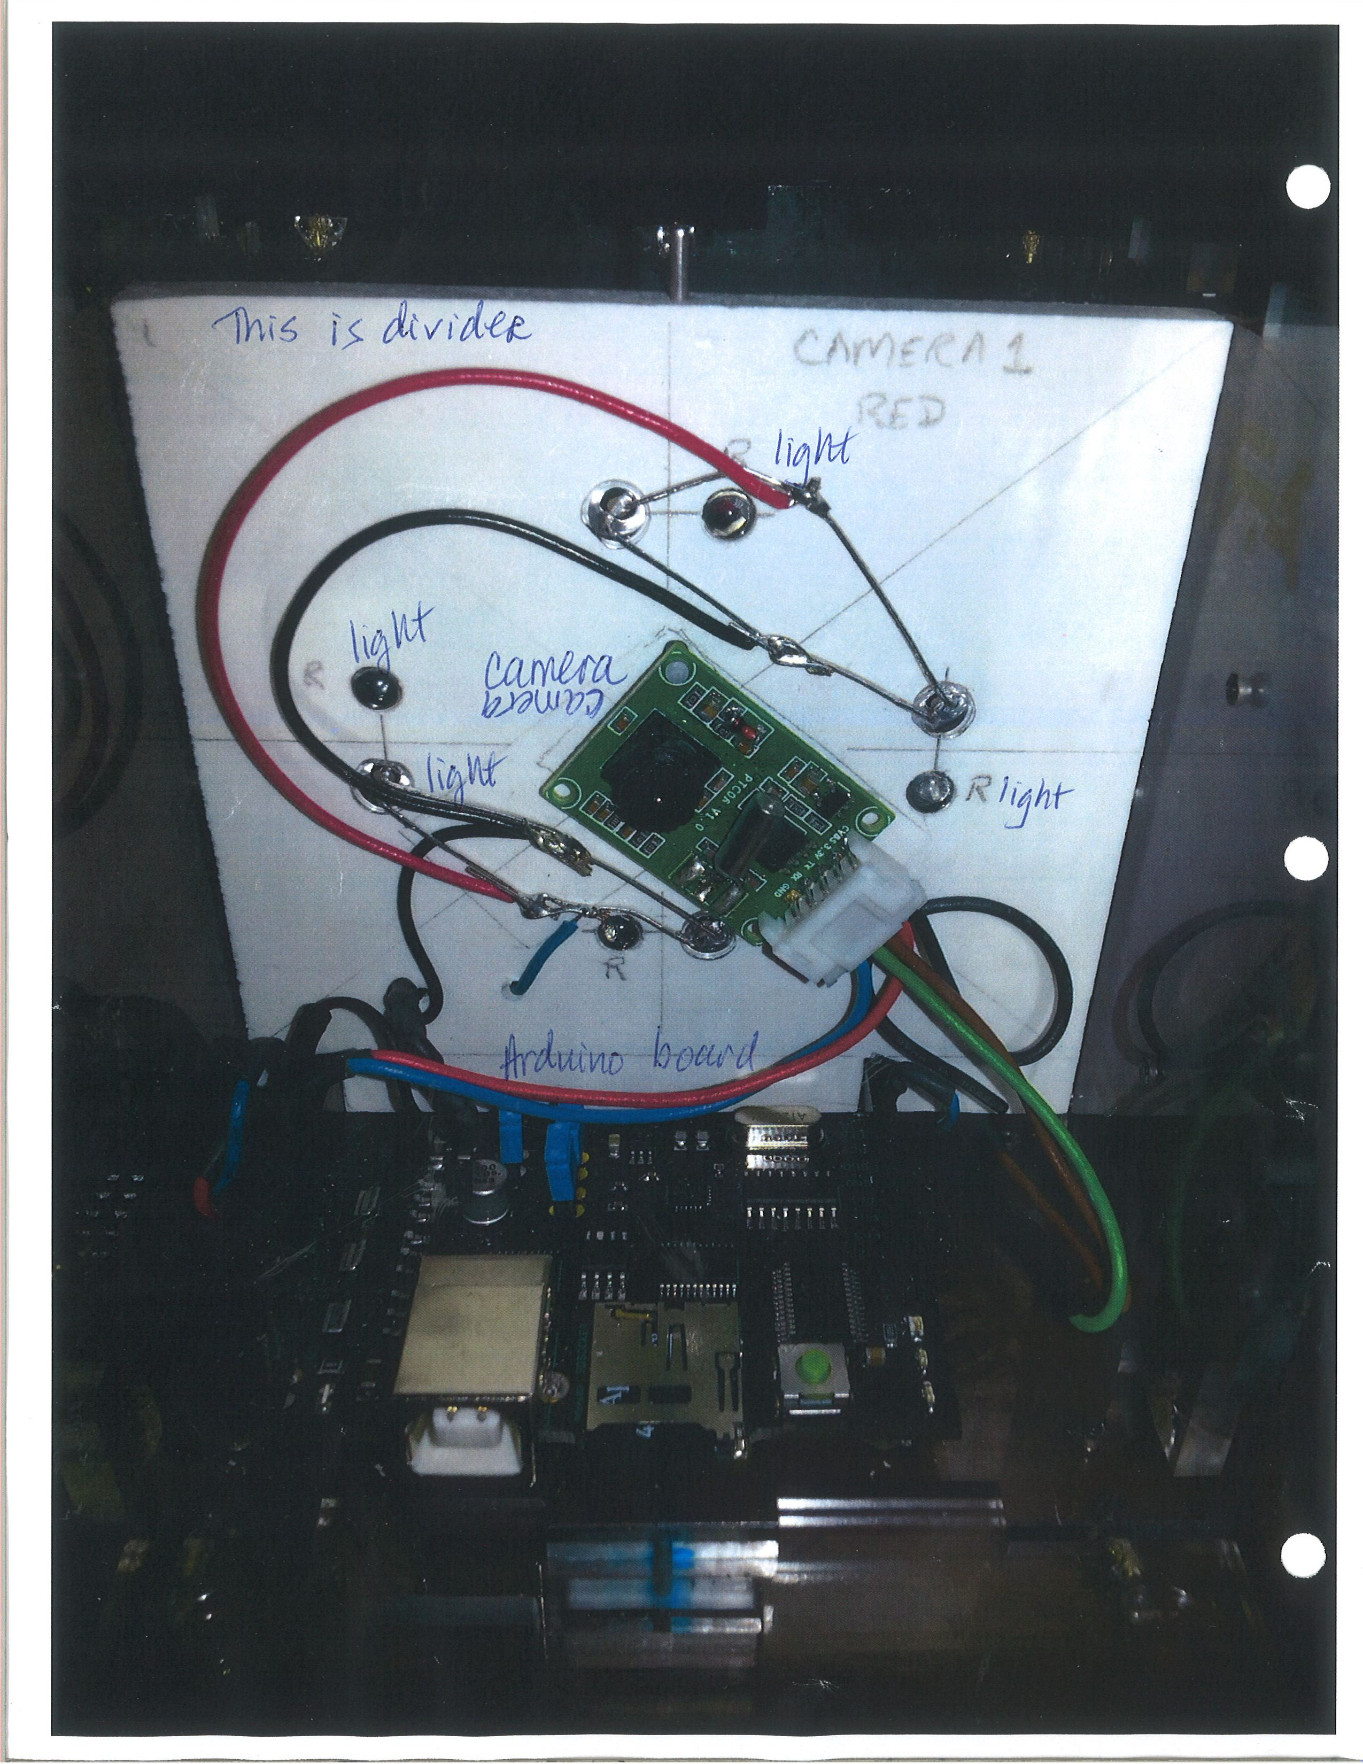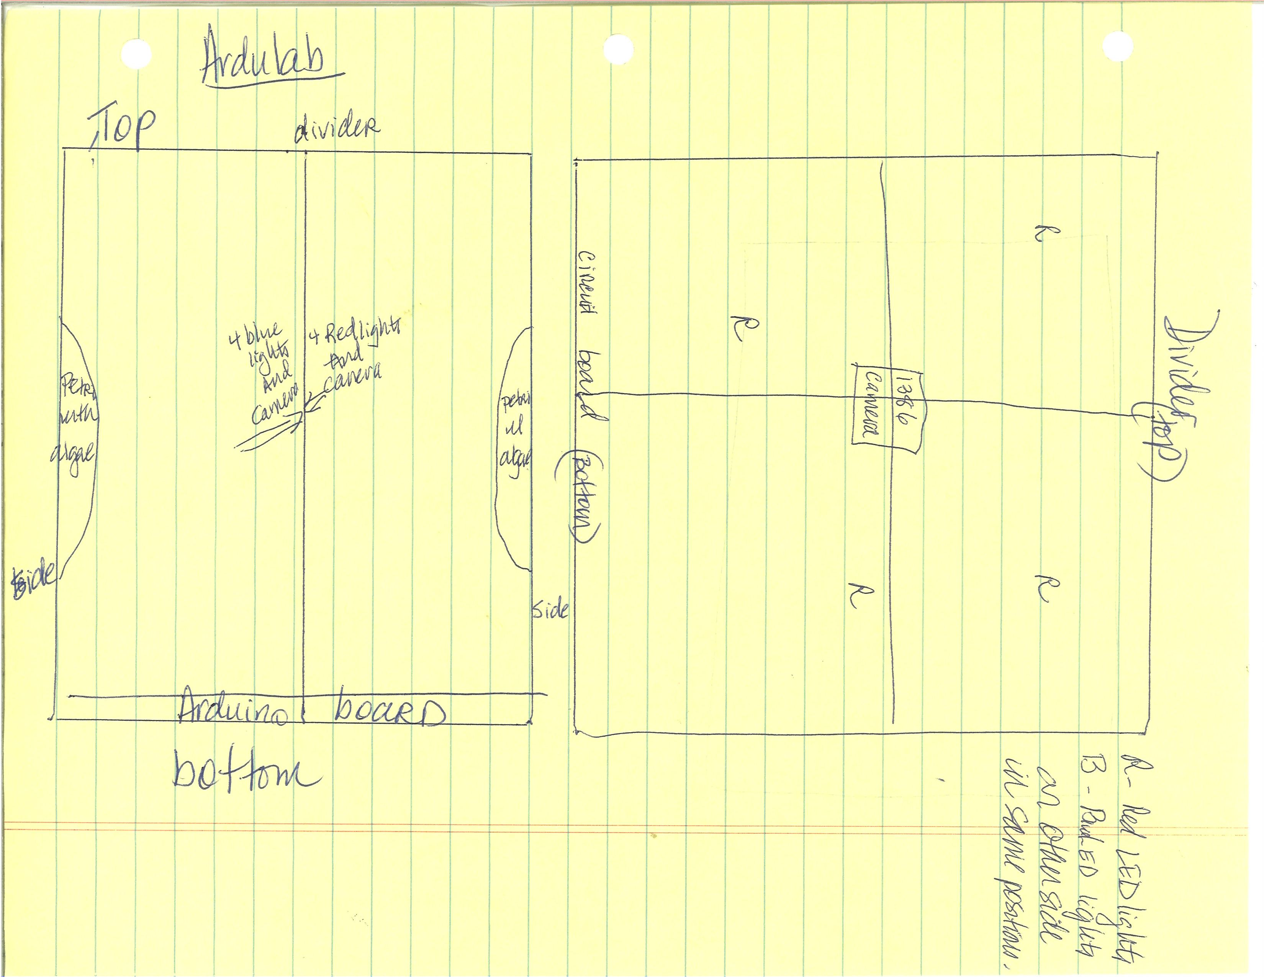
Additional Image Caption 2:
Additional Image Caption 3:

Operations Location: Indicates where the investigation is performed.

Ascent Only
Descent Only
ISS Internal
ISS External – Attached
ISS External – Deployed
Pre/Postflight
Sortie

Brief Research Operations: Brief bulleted summary of the operations and activities used to perform the investigation. Information is used in the Research and Planning Working Group (RPWG) Planning process and Crew Briefings. No more than 10 sentences.
- Destow
- Plug into one of the NanoRacks Frame-1 or 2 Module ports as soon as destowing
as possible.
- Power up the Frame
- Operate for minimum 30 days (+/- week)*
- Downlink data 3 times a week
- Destow from NanoRacks Platform Frame to pack for return to Earth on Space X5.

*NOTE: This payload can be left in the active Frame and executed as long as needed until standard time to pack for return (i.e. no hard constraint for deactivation time).

Previous Missions [nasa.gov]: None

Additional Information and Publications
(Optional for non-US Sponsored Investigations)

Detailed Research Description [nasa.gov]: Provides a place for a more technical description of the objectives of an investigation aimed at an interdisciplinary scientific audience. Several paragraphs may be used. Technical terminology should be defined to ensure readability. This field may also include a brief description of hardware and any previous names associated with the investigation.

Algae are organisms commonly found in aquatic environments. There are two types; macro-algae and microalgae. The large multi-cellular algae are often found in ponds and in the ocean. They tend to be measurable in inches, although giant kelp in the ocean can grow to more than 100 feet in length. Microalgae are tiny unicellular algae that grow as suspensions in water; they are measurable in micrometers.
Algae are a single –celled organism, but not a true plant. There are many types of algae: red, blue green, brown and green. Algae are tiny living things without roots or leaves. They are found in oceans, lakes, rivers, ponds, and wet soil. Some algae can be only being seen through a microscope. Other algae are larger and made of many cells. All algae require sunlight, water, nutrients, and carbon dioxide for growth. Through the process of photosynthesis, algae convert the carbon dioxide into glucose (a sugar). The glucose is then broken down into fatty acids, which under normal conditions, are used to produce membranes for new cells.
Algae have a very high percentage of oil. We think that algae could be used as a fuel source for cars and even an energy source on the ISS. Algae have many qualities that may help astronauts in space. It grows quickly, efficiently under certain conditions such as different wavelengths. Our experiment will determine which wavelengths and colors of light aid and benefit the growth of algae. In 2011 experiments done by Chambers, they found a trend of the best colors to grow algae. The three colors that provided the most growth are blue, green and red light. If we can test for the effect of light wavelengths on the growth of algae, then we can find the optimal color for the highest overall rate of algae growth.
Plants follow a trend of growing best under blue and red light, 475 nm and 650 nm, respectively (Chambers, 2011). Green plants reflect green light, 510 nm, which is why the plant pigment is green (Chambers, 2011). We will test red and blue wavelengths for their effect on algal growth.
Microalgae have been considered a viable source of bio-fuels, and many studies have been aimed at optimizing conditions for algal growth and lipid synthesis. In the study by Sorokin and Krauss, they investigated the effects of light wavelength on the growth rate and overall quantity of lipids synthesized by the green algae Chlorella vulgaris and other algae varieties. In Sorokin and Krauss experiment, they found that algae Chlorella vulgaris are inhibited by red wavelengths which are characteristic of a shade plant.
Our project will be conducted with red and blue LED lights. We will use Agarose to give the Chlorella vulgaris algae nutrients needed for the duration of the experiment. Air temperature will be kept constant.
We will have the red light on for 12 hours then switch the blue light on and the red light off. Every 6 hours the cameras will take a picture. We will continue this cycle for 28 days. All conditions will be kept constant. The hypothesis is that the blue light will have the largest impact on algae by accelerating growth due to the low wavelengths preferred by the Chlorella vulgaris algae. The red wavelengths are between 622 and 780 nm which will be too strong for our algae variety. However, the blue is 455 to 492nm which should be most optimal for our algae. Photosynthesis needs 450 to 650 to occur. The independent variables are the different colored wavelengths. The dependent variable is algal growth.

Operational Requirements [nasa.gov]: Defines constraints and requirements necessary to complete the investigation (number of subjects or observations, spacing of observations, downlink of data, return of samples, etc.)
Our largest constraint is the small size of the Ardulab which is 10cm by 10cm by 10cm. Also locating the correct camera that integrates with the Arduino language was difficult and time consuming. One last constraint was devising a way to water and feed the algae Chlorella vulgaris.
We would like to have data down linked 3 times a week. The data will consist of 6 photographs (3 per side of the Ardulab). We will turn on the red LED lights then take a picture, wait 6 hours and take a picture, then wait another 6 hours and take a picture. Red light turns off then blue LED light turns on and take a picture, wait 6 hours take a picture and wait another 6 hours and take a picture. Continue this for 28 days. We would like to have the Ardulab returned to Earth so that we can observe additional data.

Operational Protocols [nasa.gov]: Descriptive overview of the investigation on orbit procedures.
Destow
Plug into one of the NanoRacks Frame 1 or 2 Module ports as soon after destowing as possible.
Power up the Frame
Day 30 unplug from NanoRacks Frame and pack for return to Earth on Space X5.

Educational Impact:
Will this investigation involve students (K-12, Undergraduate, Graduate), teachers, or schools?
Yes No

Educational Activities:
Defines educational activities associated with the investigation and a brief description of student involvement.
Our fourth grade girls were involved in all aspects of this experiment. We brainstormed and voted on experiment ideas. After voting on algae, then we researched all about algae and how algae could help grow bio-fuels. Our students are becoming aware that we need to start thinking of new solutions in which to grow bio-fuels more efficiently which is an added bonus.
The girls chose what job they wanted to complete on this experiment. Some groups created patches, some were programmers, builders, news reporters, photographers, bulletin board creative directors, bloggers, ISS experts, algae experts and some chose to be managers. Each girl maintained an engineering notebook with their notes, matrices, flow charts, diagrams and the many changes that transpired weekly. Our girls are truly engineers in training and they love it!

Websites [nasa.gov]: www.ndcpilot.weebly.com

Related Investigations: Provide Investigation Names for current or past ISS investigations that have similar objectives.
LED Lights Used in Plant Growth Experiments for Deep Space Missions
HUNCH Program from Billings Central Catholic High School

Project Type: NASA Investigations Only - Indicates the primary source of project funding.
 | CASIS | NASA Research Announcement
 | Commercial | NASA Station Detailed Test Objective (SDTO)
 | Government Agency (non-NASA) | NASA Supplemental Medical Objective (SMO)
 | NASA Detailed Supplementary Objective (DSO) | Nonprofit

Grant Number: If applicable, please provide the grant number.

