Document Guidelines
- Please make every attempt to write text in present tense where applicable.
- [IDRD] indicates the field is required for the Increment Definition and Requirements Document Annex 5: Payload Tactical Plan, Table 3.0.
- Please note: After Baseline, a CEF must be submitted in order to change an [IDRD] field.
- [nasa.gov] indicates the field appears on the website http://www.nasa.gov/iss-science/.
- To check a box: double click > default value = checked > ok.
- Submit completed form to the RPWG.

Investigation/Research Common Data
(Required for All Investigations)

Investigation Name [IDRD] [nasa.gov]: NanoRacks-Awty-Yeast Cell Growth in a Microgravity Environment

Investigation Title [nasa.gov]: NanoRacks-Awty-Yeast Cell Growth in a Microgravity Environment

OpNom [nasa.gov]: NanoRacks Module-44

Principal Investigator:
- First Name [nasa.gov]: Awty International School
- Last Name [nasa.gov]:
- Email:
- Phone [(###) ###-####]: (713) 686-4850
- Mailing Address: 7455 Awty School Lane, Houston, TX 77055
- Credentials (M.D., Ph.D., M.S., etc.) [nasa.gov]:
- Institution [nasa.gov]: Awty International School
- Investigator Location [nasa.gov]: TX
- Institution Type: Academia

Co-Investigator/Collaborator:
- First Name [nasa.gov]: Jessika
- Last Name [nasa.gov]: Smith
- Email: jsmith@awty.org
- Phone [(###) ###-####]: (713) 686-4850
- Mailing Address: 7455 Awty School Lane
- Credentials (M.D., Ph.D., M.S., etc.) [nasa.gov]:
- Institution [nasa.gov]: Awty International School
- Investigator Location [nasa.gov]: TX,
- Institution Type: Academia

Person publically credited as source of this | Jessika Smith
information: | First Name Last Name

Contact:
- Primary Contact responsible for scientific content of this form:
  - First Name: Jessika
  - Last Name: Smith
  - Email: jsmith@awty.org
  - Phone [(###) ###-####]: (713) 686-4850

- Secondary Contact:
  - First Name:
  - Last Name:
  - Email:
  - Phone [(###) ###-####]:

Developer(s) [nasa.gov]: NanoRacks LLC, Houston, TX

Sponsoring Space Agency [IDRD] [nasa.gov]:
National Aeronautics and Space Administration (NASA)

Sponsoring Organization [nasa.gov]:
National Laboratory Education (NLE)

Research Benefits [nasa.gov]: Does the research have potential benefits in the following areas? (Choose all that apply.)
Earth Benefits
Scientific Discovery
Space Exploration

Increment(s) [IDRD] [nasa.gov]: Inc 39/40

Number of Investigations: (Increment Specific) One.

PAO Summary (“Research Objectives” in IDRD) [IDRD] [nasa.gov]: NanoRacks-Awty-Yeast Cell Growth in a Microgravity Environment tests and determines the effects of microgravity on yeast cells. The investigation examines the cellular growth rate, cellular structure and the process of cellular respiration. Understanding the effects of microgravity on yeast cells, because they closely resemble how human cells function, helps us to better understand what is happening to the human body in space.
Research Overview [nasa.gov]:
- NanoRacks-Awty-Yeast Cell Growth in a Microgravity Environment investigates the cellular growth rate, cellular structure and the process of cellular respiration of three strains of yeast in microgravity.
- Learning how microgravity affects the amount of carbon dioxide produced contributes to the development of air recycling and filtration for long-duration missions.
- Using visual images taken with a camera, NanoRacks-Awty-Yeast Cell Growth in a Microgravity Environment measures the rate of growth of three different strains of yeast using the same growth media.
- This experiment uses a standard 1.0 U (10 cm x 10 cm x 10 cm) NanoRacks Module consisting of an aluminum ArduLab. It contains a y-plate with agar and yeast. There are sensors including a temperature/humidity sensor and a carbon dioxide sensor. A camera and two bright LED lights are installed. An RTC clock has been installed to organize data as it is collected.
- Upon return to Earth, the make-up/cell structure is analyzed to determine how microgravity affects the cells.
- Using a carbon dioxide sensor, the levels of carbon dioxide are measured to determine if a microgravity environment affects the levels of gas produced.
- Medical research uses yeast cell studies to investigate advances/hypotheses in the effectiveness of medicines and also how the microgravity environment affects the human body.

Space Applications [nasa.gov]: Understanding the effects of microgravity on the cell helps to better understand what is happening to the human body in space. In addition, learning how microgravity affects the amount of carbon dioxide produced can contribute to the development of air recycling and filtration for long duration missions.
Earth Applications [nasa.gov]: Yeast cells closely resemble human cells and studying them may allow for biological studies of human cells and the effectiveness of medicines.

Category [IDRD] [nasa.gov]: Educational Activities and Outreach
Subcategory [nasa.gov]: Student-Developed Investigations

Hardware Description [IDRD]: (Increment Specific) NanoRacks Module-44 P/N NRP-10044, S/N 1001: a 10 x 10 x 10 cm module for standard power/data interface with the NanoRacks Platform for USB power and data transfer. The Module utilizes an ArduLab structure (same micro-control board as approved for NanoRacks Module-39 that went up on ORB-1). The ardulab is entirely aluminum.

Unique Payload Constraints [IDRD]: (Increment Specific) Cold Stowage +4C is required pre flight and through return on Space X 5. SPECIAL ORIENTATION: The ardulab will need to placed into storage for flight with the Y-plate on the bottom of the ardulab. (see picture below) The experiment needs plugged into the NanoRacks Platform and powered-up for 30 days of operations (+/- 4 days) before return. The ardulab can be plugged in immediately upon removal from cold stowage.

Imagery [nasa.gov]: Submit images, drawings, and graphical data separately in a high resolution (1MB or larger) .jpg format with the completed Investigation Summary Form. Image caption should have a detailed description of the image contents, activity occurring in the image, a NASA number if available, names of the individuals in the image, and image credit information. The primary image is used for communication projects. Images of the investigation on the ISS will be added following operation.

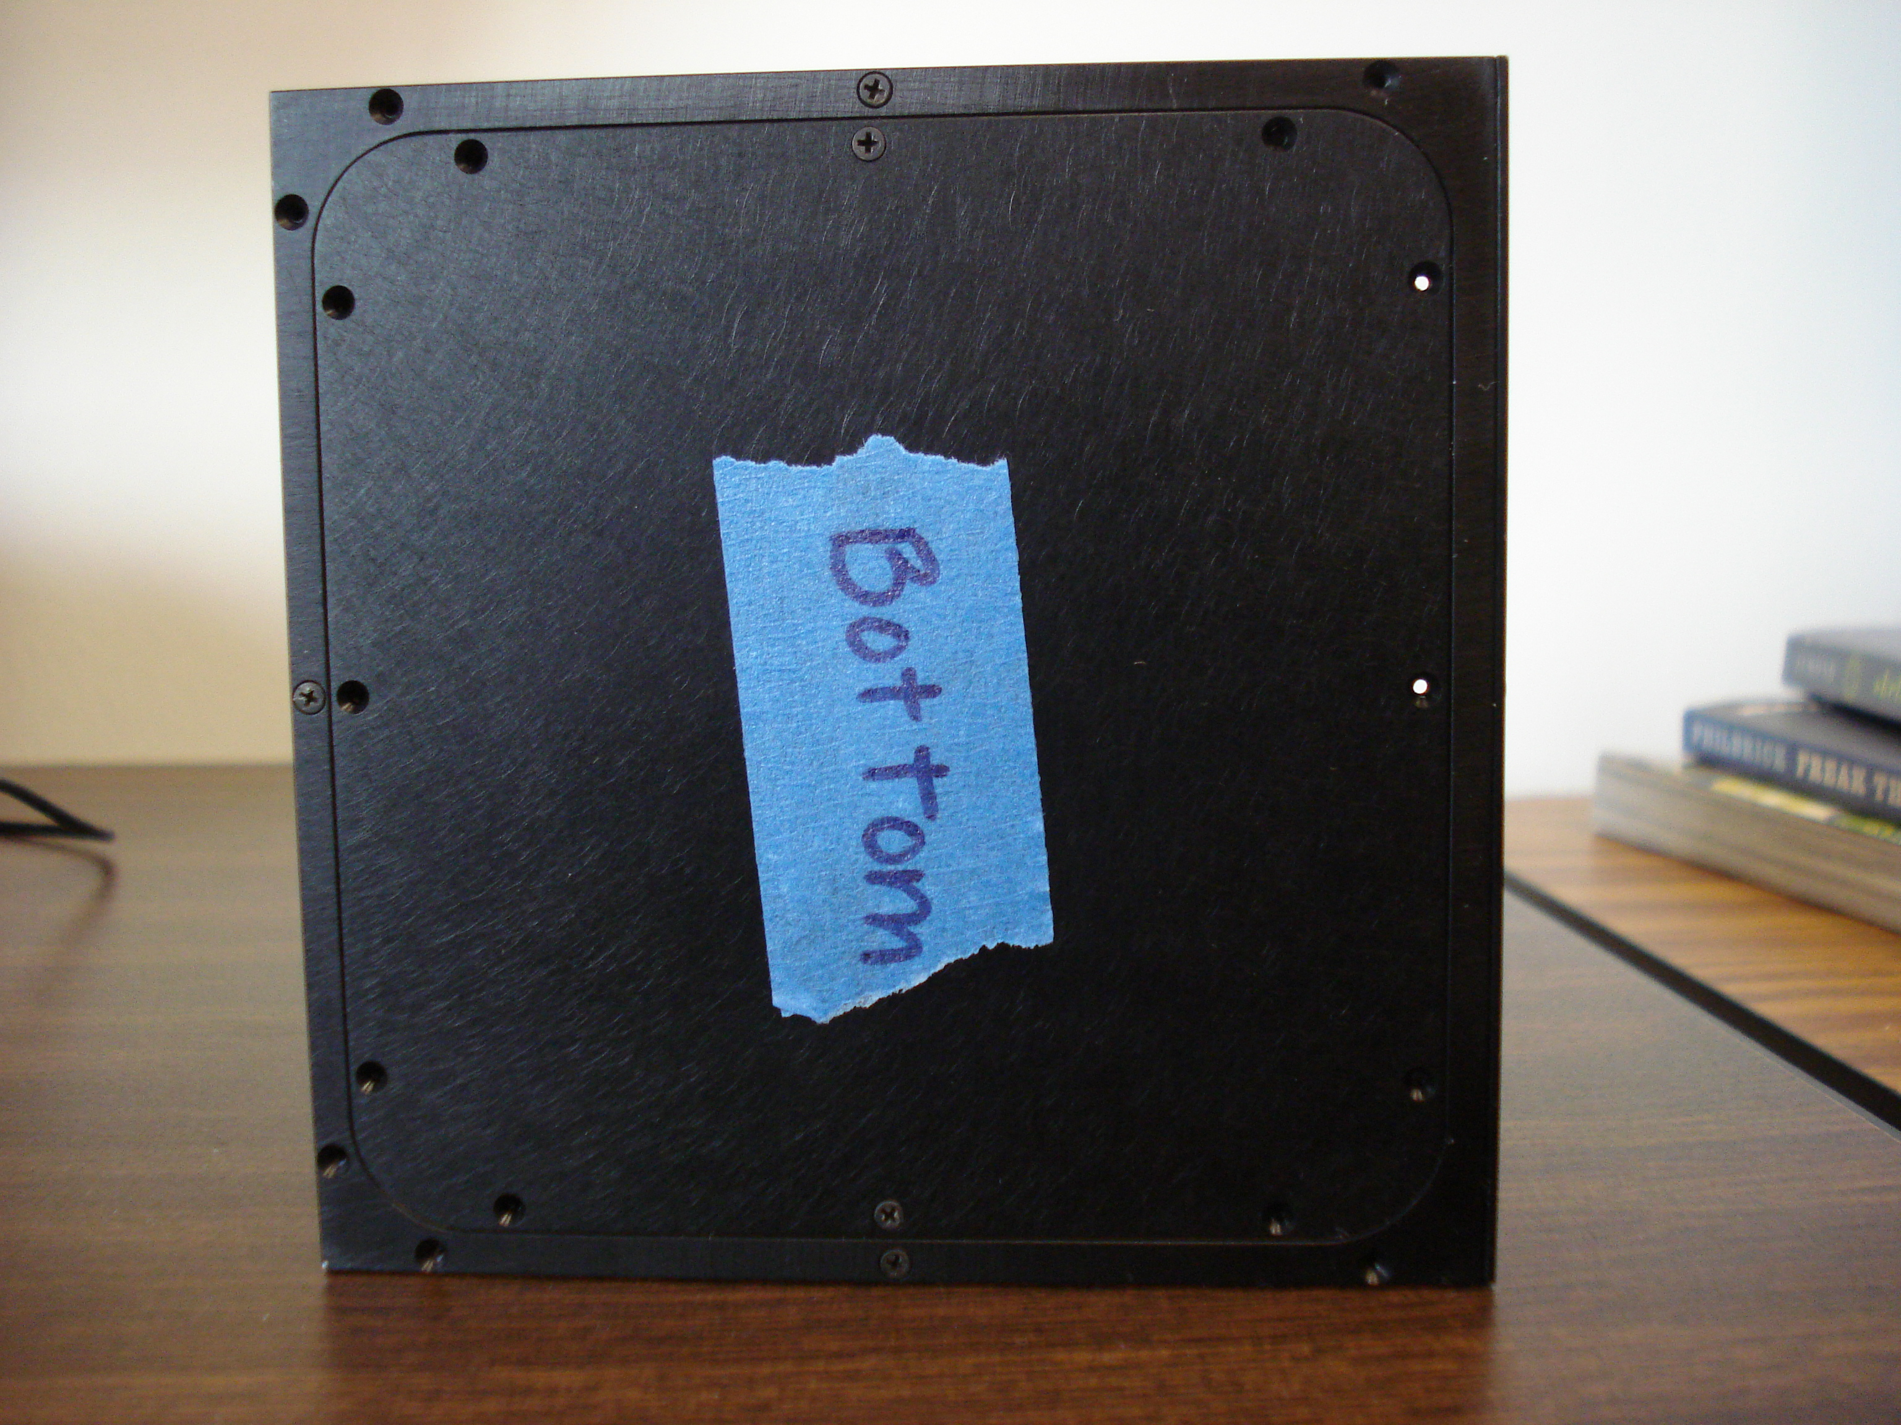
Primary Image Caption: The NanoRacks-Awty-Yeast Cell Growth in a Microgravity Environment experiment module (orientation for launch/return). Image courtesy of Awty International School.

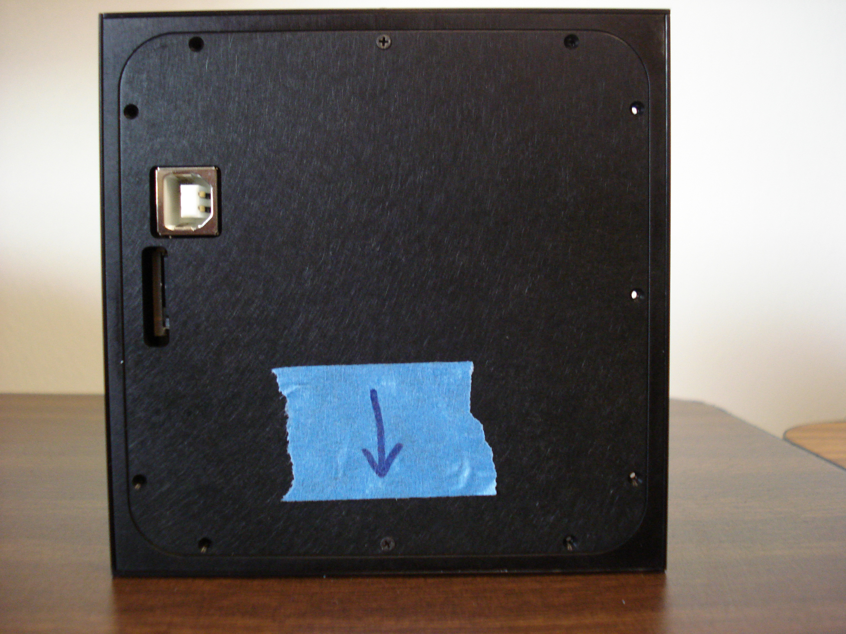
Additional Image Caption 2: The NanoRacks-Awty-Yeast Cell Growth in a Microgravity Environment experiment module (orientation for launch/return). Image courtesy of Awty International School.

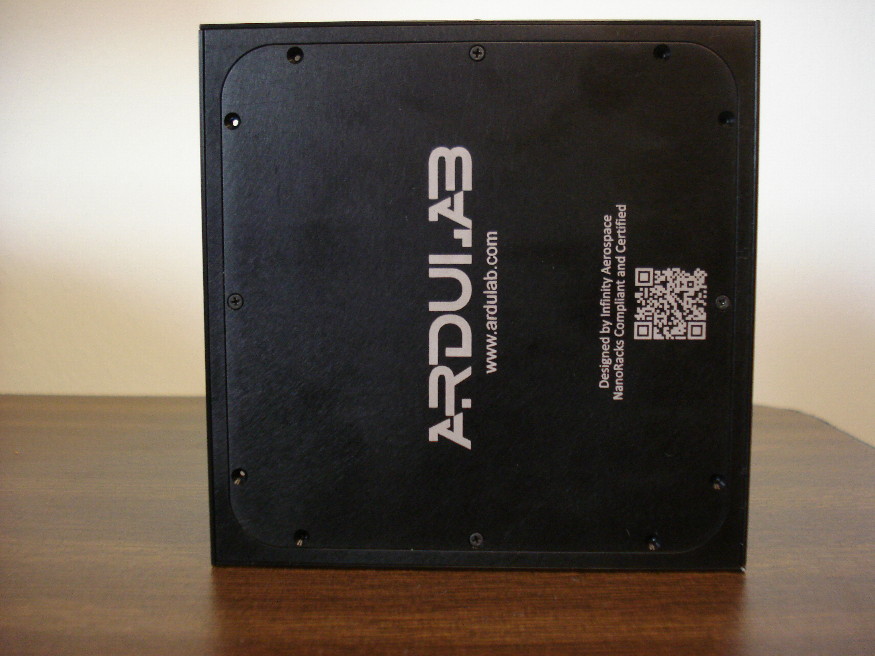
Additional Image Caption 3: The NanoRacks-Awty-Yeast Cell Growth in a Microgravity Environment experiment module (orientation for launch/return). Image courtesy of Awty International School.

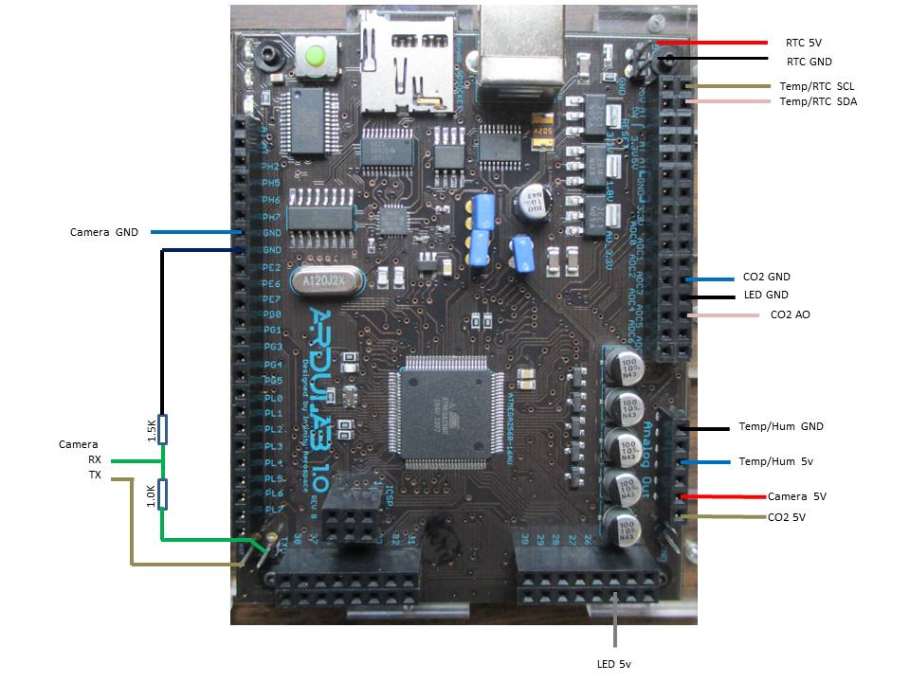
Additional Image Caption 4: The NanoRacks-Awty-Yeast Cell Growth in a Microgravity Environment ArduLab Microcontroller. Image courtesy of Awty International School.

Operations Location: ISS Internal

Brief Research Operations: Brief bulleted summary of the operations and activities used to perform the investigation. Information is used in the Research and Planning Working Group (RPWG) Planning process and Crew Briefings. No more than 10 sentences.
time).
- Crewmember destows NanoRacks Modules 41-47.
- The NanoRacks Modules are plugged into the NanoRacks Platform.
- Power up the NanoRacks Platform and operate for minimum of 30 days.
  - NanoRacks Module-44 can remain in the Platform and executed as long as needed until standard time to pack for return (i.e. no hard constraint for deactivation time).
- Crewmember destows the Modules from NanoRacks Platform and pack for return on SpX-5.

Previous Missions [nasa.gov]: None

Additional Information and Publications
(Optional for non-US Sponsored Investigations)

Detailed Research Description [nasa.gov]: Provides a place for a more technical description of the objectives of an investigation aimed at an interdisciplinary scientific audience. Several paragraphs may be used. Technical terminology should be defined to ensure readability. This field may also include a brief description of hardware and any previous names associated with the investigation.

NanoRacks-Awty-Yeast Cell Growth in a Microgravity Environment joins other studies that look at cell growth and development in a microgravity environment. Medical research uses yeast cell studies to investigate advances/form hypotheses on the effectiveness of medicines. Researchers also study how the microgravity environment affects the human body and cell structure. Students learned that yeast cells are often studied in space because they closely resemble how human cells function. In addition, students understand that NASA no longer expects to take astronauts to the moon, or the International Space Station (ISS) once it is deorbited. Rather, NASA is looking towards a loftier goal of placing a man or woman on Mars. This spaceflight would be considerably longer than other missions. It is important to continue research in this field to gain as much knowledge as possible to better prepare/protect and treat the men and women who travel to space. The student research team understands that humans produce carbon dioxide (CO₂) as a waste product. They are interested in determining if cells produce more CO₂ in a microgravity environment than on earth. This information is necessary as engineers develop air recirculation systems for vessels traveling further into the galaxy.

NanoRacks-Awty-Yeast Cell Growth in a Microgravity Environment sends three different strains of yeast in one growth medium to a microgravity environment. The yeast selected are Saccharomyces cerevisiae, Saccharomyces ellipsoideus, Schizosaccharomyces pombe. A camera is used to determine rate of growth. A temperature and humidity sensor measures the environmental conditions surrounding the yeast. Finally, a carbon dioxide sensor compares levels of carbon dioxide being produced. It will also serve as a fail-safe to ensure the yeast are continuing to grow if camera operations are lost. Ground experiments are run simultaneously for comparison data. Cell structure is evaluated upon return to Earth.

Operational Requirements [nasa.gov]: NanoRacks Module-44 needs to be kept in cold stowage +4°C until ready for plug-in. Once plugged in, data is downlinked three times per week. Once unplugged and prepared for return flight, NanoRacks Module-44 must again be placed in cold stowage to ensure the yeast become inactive.

Operational Protocols [nasa.gov]:
NanoRacks Module-44 is destowed immediately in order to have the maximum number of days possible to obtain data. It is plugged into the NanoRacks Platform and operates autonomously for a minimum of 30 days. NanoRacks Module-44 returns cold stowage at +4°C on SpX-5.

Educational Impact:
Will this investigation involve students (K-12, Undergraduate, Graduate), teachers, or schools?
Yes No

Educational Activities:
Early on in the process, students formulated their groups based on interests ranging from learning the science, to experiencing the engineering. All groups have learned how to work through the scientific method and have an understanding of testing, collecting data, comparing observations and formulating conclusions. Students have had the opportunity to learn and practice skills related to creating sterile plates. This includes autoclaving, pouring plates, looping the yeast and streaking the plate. Students have collected and compared data related to yeast growth in class. Heavy research has been conducted relating to yeast and eukaryotic structure, yeast cell studies in space, and the different strains of yeast used. In addition, students have researched at length, the different sensors/monitors necessary to collect data while the ArduLab is aboard the ISS. Finally, this has allowed the class an opportunity to see how careers related to fields of Science, Technology, Engineering and Math (STEM) are applicable now, and when they become adults choosing career paths.

Websites [nasa.gov]: www.ndcpilot.weebly.com

Related Investigations: Provide Investigation Names for current or past ISS investigations that have similar objectives.

Project Type: CASIS

Grant Number: If applicable, please provide the grant number.

