Document Guidelines
- Please make every attempt to write text in present tense where applicable.
- [IDRD] indicates the field is required for the Increment Definition and Requirements Document Annex 5: Payload Tactical Plan, Table 3.0.
- Please note: After Baseline, a CEF must be submitted in order to change an [IDRD] field.
- [nasa.gov] indicates the field appears on the website http://www.nasa.gov/iss-science/.
- To check a box: double click > default value = checked > ok.
- Submit completed form to the RPWG.

Investigation/Research Common Data
(Required for All Investigations)

Investigation Name [IDRD] [nasa.gov]: NanoRacks-Duchesne-Plant Growth Chamber

Investigation Title [nasa.gov]: NanoRacks-Duchesne-The Effects of Microgravity and Light Wavelength on Plant Growth in an ArduLab

OpNom [nasa.gov]: NanoRacks Module-46

Principal Investigator:
- First Name [nasa.gov]: Duchesne Academy of the Sacred Heart
- Last Name [nasa.gov]:
- Email:
- Phone [(###) ###-####]: (713) 468-8211
- Mailing Address: 10202 Memorial Drive, Houston, TX 77024
- Credentials (M.D., Ph.D., M.S., etc.) [nasa.gov]:
- Institution [nasa.gov]: Duchesne Academy of the Sacred Heart
- Investigator Location [nasa.gov]: TX
- Institution Type: Academia

Co-Investigator/Collaborator:
- First Name [nasa.gov]: Kathy
- Last Name [nasa.gov]: Duquesnay
- Email: kathy.duquesnay@duchesne.org
- Phone [(###) ###-####]: (713) 468-8211 ext 286 or 713-419-7670
- Mailing Address: 10202 Memorial Dr., Houston, Tx 77024
- Credentials (M.D., Ph.D., M.S., etc.) [nasa.gov]: M. Ed.
- Institution [nasa.gov]: Duchesne Academy of the Sacred Heart
- Investigator Location [nasa.gov]: TX, USA
- Institution Type: Academia

Person publically credited as source of this | Kathy Duquesnay
information: | First Name Last Name

Contact:
- Primary Contact responsible for scientific content of this form:
  - First Name: Kathy
  - Last Name: Duquesnay
  - Email: kathy.duquesnay@duchesne.org
  - Phone [(###) ###-####]: (713) 468-8211 ext 286 or 713-419-7670

- Secondary Contact:
  - First Name:
  - Last Name:
  - Email:
  - Phone [(###) ###-####]:

Developer(s) [nasa.gov]: NanoRacks LLC, Houston, TX

Sponsoring Space Agency [IDRD] [nasa.gov]:
National Aeronautics and Space Administration (NASA)

Sponsoring Organization [nasa.gov]:
National Laboratory Education (NLE)

Research Benefits [nasa.gov]: Does the research have potential benefits in the following areas? (Choose all that apply.)
Earth Benefits
Scientific Discovery
Space Exploration

Increment(s) [IDRD] [nasa.gov]: Inc 39/40

Number of Investigations: (Increment Specific) One.

PAO Summary (“Research Objectives” in IDRD) [IDRD] [nasa.gov]: NanoRacks-Duchesne-The Effects of Microgravity and Light Wavelength on Plant Growth in an ArduLab (NanoRacks-Duchesne-Plant Growth Chamber) tests the effect of combinations of red and blue wavelengths of electromagnetic radiation on pea shoot plants, a small fast growing plant. The plants are started from seeds, placed in a 10 cubic centimeter ArduLab and grown in a microgravity environment. This experiment is important so that plants with high nutrition can be effectively and rapidly grown on the International Space Station (ISS) and on future long-duration flights.
Research Overview [nasa.gov]: Bulleted list slightly more detailed than the PAO summary, written on the 8th grade level. The Research Overview should highlight why the research is needed, what the research accomplishes, and what the impact of the research is. The selection process for a nutritional, rapidly growing plant that could be easily grown from seeds led us to three vegetables commonly eaten as shoots. In their early stages of life, peas, popcorn shoots, and bamboo could be used as test subjects to observe the speed of growth under different wavelengths of light. Pea shoots contain high amounts of Vitamin A, B, C, E, calcium, chlorophyll, iron, magnesium, niacin, phosphorus, potassium, amino acids, and protein up to 25%. In additional to their nutritional values, they are also low in sodium, fat, and sugar. They can be harvested after only two to four weeks of growth, and have a seed shelf life of four to five years. Popcorn shoots also contain Vitamin A, B, C, E, calcium, chlorophyll, iron, lecithin, magnesium, pantothenic acid, phosphorus, potassium, trace elements, and around 30% protein. However, popcorn seeds only take between eight to twelve days to sprout. In addition to pea and popcorn shoots, bamboo shoots are also highly beneficial. Studies show that bamboo can prevent the production of cancerous cells, improve appetite and digestion, aid weight loss, and treat hypertension and hyperglycemia. The main nutrients include high levels of protein, amino acids, healthy fats and sugars, salt, and water contents.

We are planning to use a combination of red and blue LED lights. According to our research, a mixture of red and blue lights provides the optimal wavelength to induce favorable plant growth.

Professor Allen Barker at University of Massachusetts Amherst stated that 450 and 650 nanometers are required for photosynthesis, and red light has wavelengths between 622 and 780 nm. Blue light has between 455 to 492 nm, and violet light has between 390 and 455 nm. Also between 650 and 730 nm wavelengths allow the plant to flower by influencing the phytochrome plant pigment.

NASA has used white, green, and red lights in the past; this is one of the reasons we have decided on these colors. Red LED lights have been proven by NASA to cause the plants to have a “higher concentration of anthocyanin, an antioxidant that can combat some of the effects of cosmic radiation” (LED Lights Used in Plant Growth Experiments for Deep Space Missions). Another NASA study concluded that green lights are also beneficial to plants. NASA believes the light is important because of the positive effects, like an increase of antioxidants, can have on the plants.

A space experiment called VEGGIE, short for plant growing system about the size of a microwave oven, to be sent onto the ISS on Dec. 9 2013. The experiment called for red and blue LED lights for photosynthesis to take place and to make experiments. LED lights are being used because of their long lifetime.

From October 2009 to September 2010, scientists grew a garden of thale cress on ISS in an experiment called ADSVAC, which tested the Advanced Astroculture Plant Growth Chamber. Scientists genetically modified these plants to under how stress in a zero gravity environment was affecting the plants. When they genetically modified the plants, it allowed them to glow when they were unhappy. This was helpful because it meant they could examine the plant without dissecting it.

Seeds in space followed the same sprouting pattern and growth stages as the plants here on Earth. Many scientist were concerned that the roots would grow incorrectly because it was thought that gravity had an effect on the downward formation of the roots. After NASA had conducted a successful experiment on the international space station, it is known that gravity is not necessary to growing plants.

In 2010, the ISS was sent plants called Arabidopsis thaliana or Thale Cress. These plants were used to study how plant roots developed in a weightless environment. These plants were grown on a nutrient-rich gel in clear petri plates. These plants showed familiar root growth patterns where roots slant progressively as they branch out. Researchers have always thought that direction of growth was the result of gravity's effects on root tip growth. Others think that in microgravity, other factors take over that enable the plant to direct its roots away from the seed and light-seeking shoot. Those factors could include moisture, nutrients, and light.
A study was done at the University of Wisconsin and at Kennedy Space center growing wheat plants with only red lights. The plants were dying, thin, and very "pale" because of the loss of chlorophyll. Blue fluorescent lights repaired most of the problems caused by the blue LEDS. In the September of 2012 NASA ran and experiment monitoring the growth of radish plants versus red leafed lettuce and in different types of lights and light levels. A chlorophyll meter was used to measure the amount of chlorophyll in a plant. Afterwards, the plants were frozen in liquid nitrogen and were pulverized into a new powdery form. The powder would be used to run a new test in which the amount of stored energy in the plant tissue would be measured. The plants were grown in red, blue, white, and green LED lights. Some lights increase nutrients and antioxidant. The lettuce and radishes showed darker red color under the red and blue LED lights, some nutrients found in red leafed lettuce thrived in the red light. Some of these nutrients fight cosmic radiation. Ongoing experiments are currently further investigating the topic.
Information is used in the Research and Planning Working Group (RPWG) Planning process and Crew Briefings.

- NanoRacks-Duchesne-The Effects of Microgravity and Light Wavelength on Plant Growth in an ArduLab (NanoRacks-Duchesne-Plant Growth Chamber) uses a standard 1.0 U (10 cm x 10 cm x 10 cm) NanoRacks Module consisting of a LEXAN™ ArduLab covered in Aluminum tape (High Temperature 3M™ Aluminum Tape) containing red and blue LED lights, 2 cameras, broccoli and pea seeds in Phytoblend agar with nutrients as the growth media

- NASA has used white, green, and red lights in the past; this is one of the reasons these colors are used. Red LED lights have been proven by NASA to cause the plants to have a “higher concentration of anthocyanin, an antioxidant that can combat some of the effects of cosmic radiation” Another NASA study concluded that green lights are also beneficial to plants. NASA believes the light is important because of the positive effects, like an increase of antioxidants, can have on the plants.

Space Applications [nasa.gov]: This experiment is important so that plants with high nutrition can be effectively and rapidly grown on the ISS and on future long duration flight. The purpose is to identify the combination of red and blue LEDs that induces the most rapid growth.
Earth Applications [nasa.gov]: This experiment has the potential of helping understand how to grow nutritious vegetables using minimal light energy, nutrients, and space. These results can be put to use in various locations throughout the world.
Category [IDRD] [nasa.gov]: Educational Activities and Outreach
Subcategory [nasa.gov]: Student-Developed Investigations

Hardware Description [IDRD]: (Increment Specific) NanoRacks Module-46 P/N NRP-10046, S/N 1001: a 10 x 10 x 10 cm module for standard power/data interface with the NanoRacks Platform for USB power and data transfer. The Module utilizes an ArduLab structure (same micro-control board as approved for NanoRacks Module-39 that went up on ORB-1). Made out of anodized aluminum.

Unique Payload Constraints [IDRD]: (Increment Specific) The experiment needs to be cold stowed +4C both before launch and upon return on Space X 5. The experiment needs plugged into the NanoRacks Platform and powered-up for 30 days of operations (+/- 4 days) before return.

Imagery [nasa.gov]: Submit images, drawings, and graphical data separately in a high resolution (1MB or larger) .jpg format with the completed Investigation Summary Form. Image caption should have a detailed description of the image contents, activity occurring in the image, a NASA number if available, names of the individuals in the image, and image credit information. The primary image is used for communication projects. Images of the investigation on the ISS will be added following operation.

Primary Image Caption: Diagram of NanoRacks Module- in Sketchup
Additional Image Caption 1: 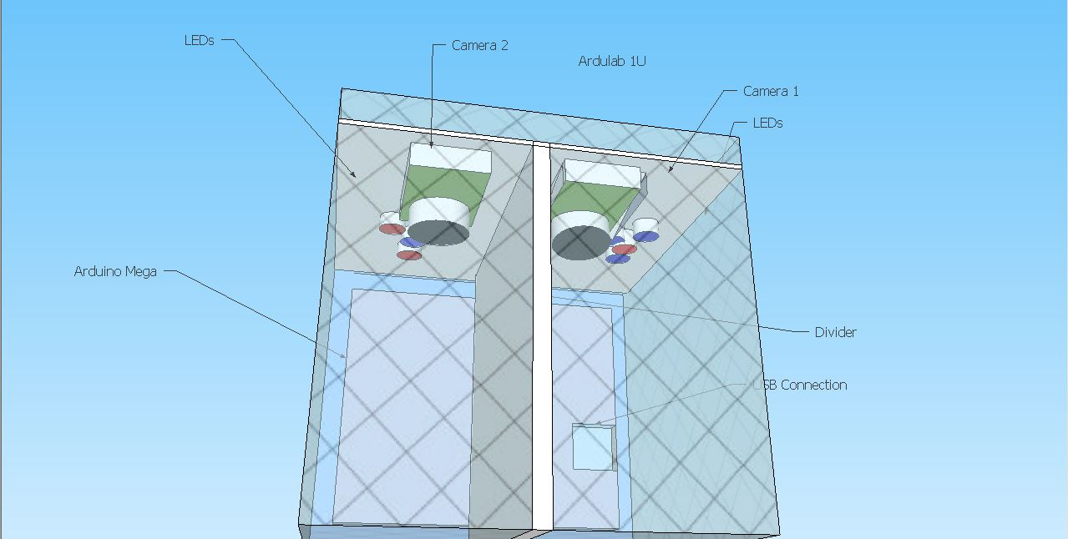

Diagram of the experiment design
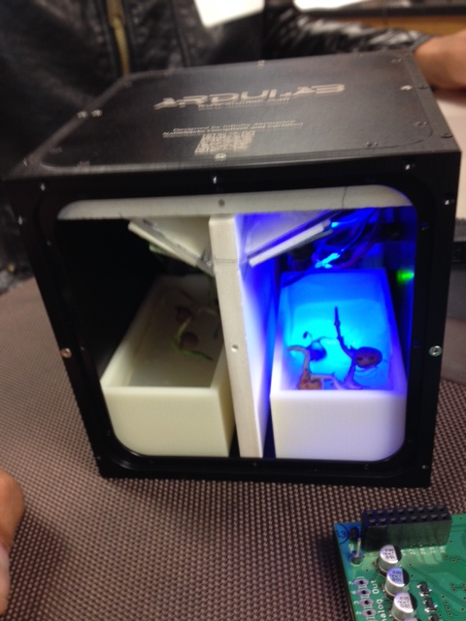
Additional Image Caption 2: Ardulab showing peas growing under 3 Blue and 1 red LED
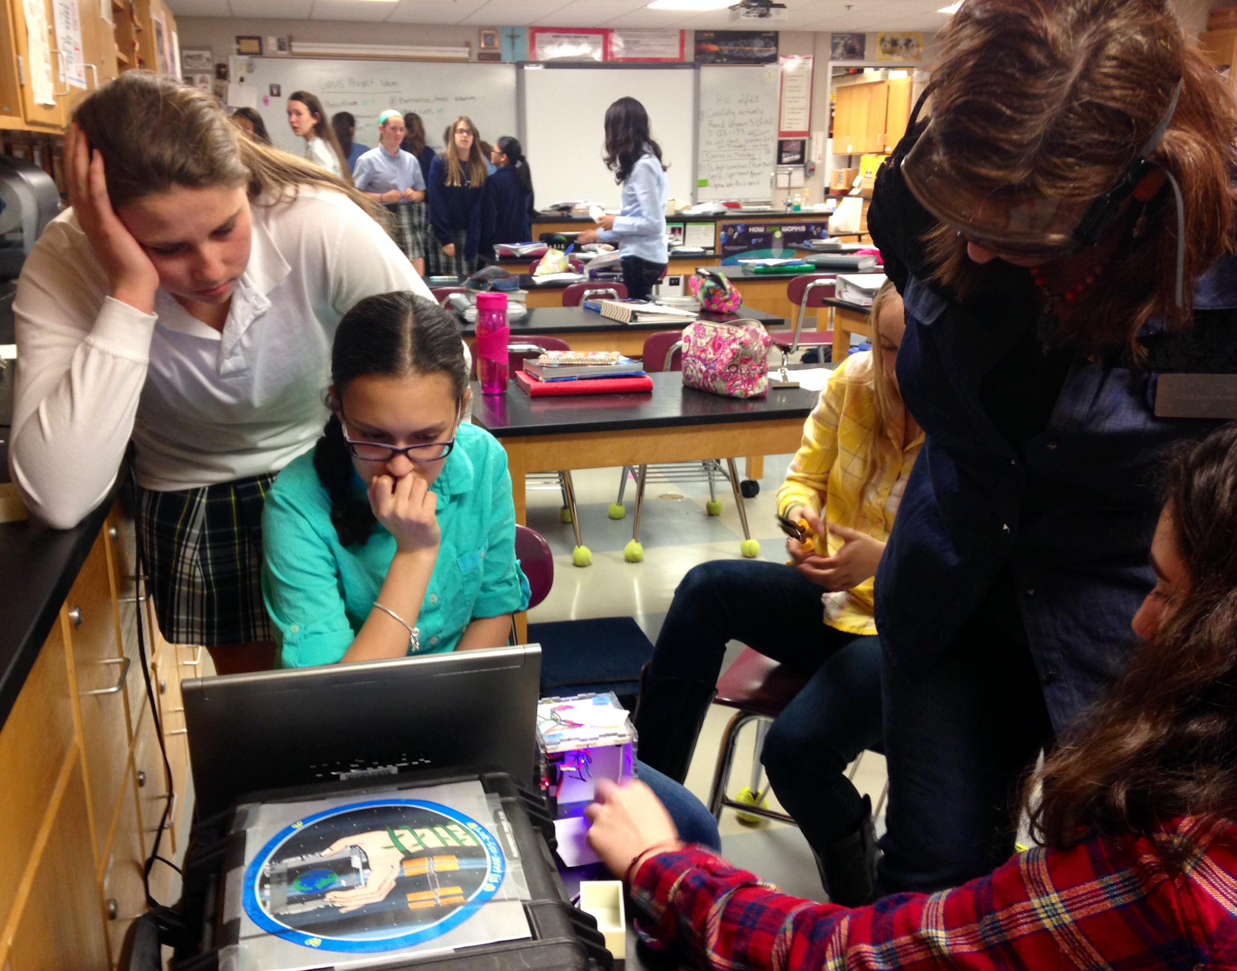

Additional Image Caption 3: Students focusing the cameras

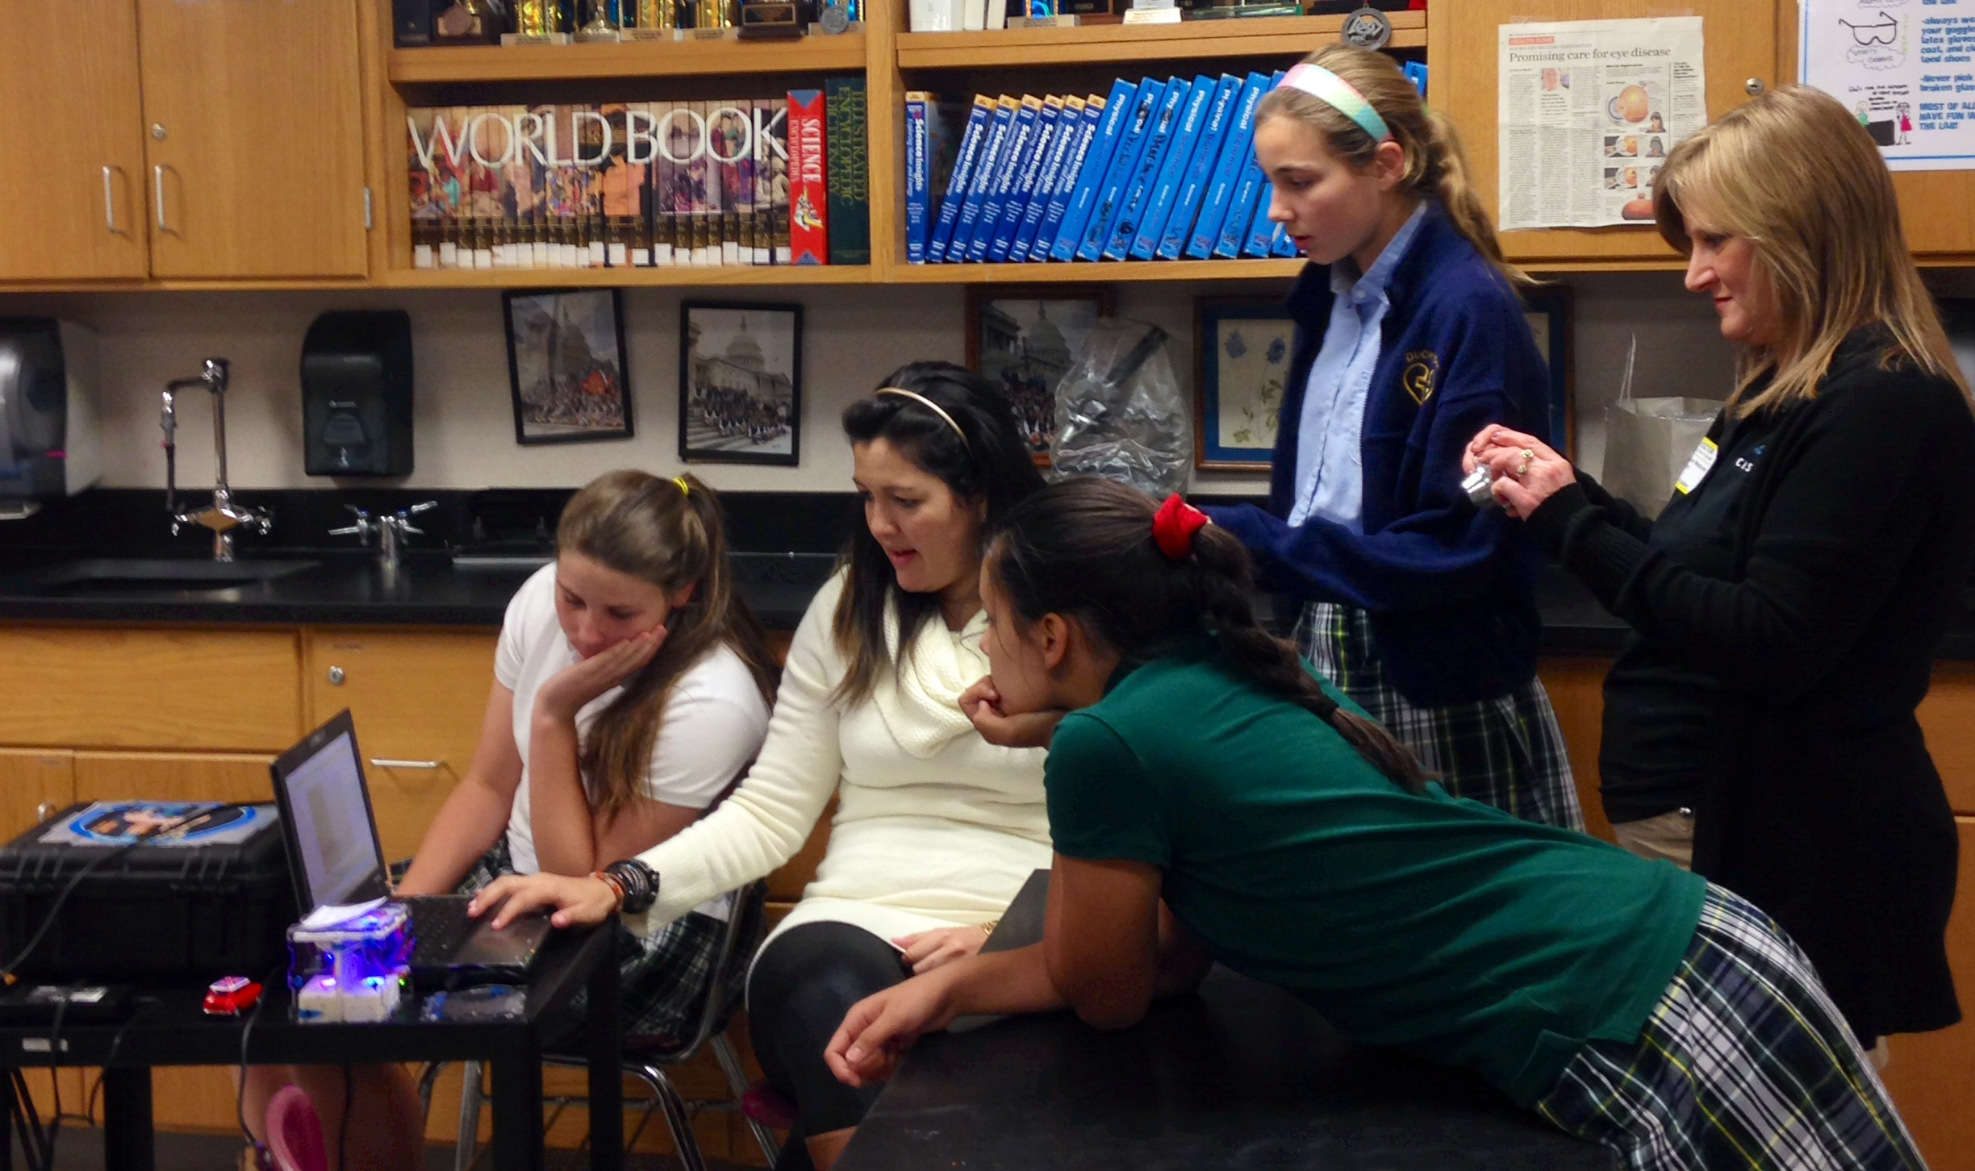
Students working with Ms. Livia Santos focusing the cameras with Ms. Alli Westover looking on.

Operations Location: ISS Internal

Brief Research Operations: Brief bulleted summary of the operations and activities used to perform the investigation. Information is used in the Research and Planning Working Group (RPWG) Planning process and Crew Briefings. No more than 10 sentences.

- Crewmember destows NanoRacks Modules 41-47.
- The NanoRacks Modules are plugged into the NanoRacks Platform.
- Power up the NanoRacks Platform and operate for minimum of 30 days.
  - NanoRacks Module-46 can remain in the Platform and executed as long as needed until standard time to pack for return (i.e. no hard constraint for deactivation time).
- Crewmember destows the Modules from NanoRacks Platform to pack for return on SpX-5.

Previous Missions [nasa.gov]: None

Additional Information and Publications
(Optional for non-US Sponsored Investigations)

Detailed Research Description [nasa.gov]: Provides a place for a more technical description of the objectives of an investigation aimed at an interdisciplinary scientific audience. Several paragraphs may be used. Technical terminology should be defined to ensure readability. This field may also include a brief description of hardware and any previous names associated with the investigation.

The selection process for a nutritional, rapidly growing plant that is easily grown from seeds led to several vegetables commonly eaten as shoots. In their early stages of life, peas, popcorn shoots, broccoli shoots, and bamboo make excellent test subjects to observe the speed of growth under different wavelengths of light. Pea shoots contain high amounts of Vitamin A, B, C, E, calcium, chlorophyll, iron, magnesium, niacin, phosphorus, potassium, amino acids, and protein up to 25%. In additional to their nutritional values, they are also low in sodium, fat, and sugar. They can be harvested after only two to four weeks of growth, and have a seed shelf life of four to five years. Popcorn shoots also contain Vitamin A, B, C, E, calcium, chlorophyll, iron, lecithin, magnesium, pantothenic acid, phosphorus, potassium, trace elements, and around 30% protein. However, popcorn seeds only take between eight to twelve days to sprout. In addition to pea and popcorn shoots, bamboo shoots are also highly beneficial. Studies show that bamboo can prevent the production of cancerous cells, improve appetite and digestion, aid weight loss, and treat hypertension and hyperglycemia. The main nutrients include high levels of protein, amino acids, healthy fats and sugars, salt, and water contents. Broccoli sprouts are known for their antioxidant properties. They contain especially high amounts of sulforaphane.
NanoRacks-Duchesne-The Effects of Microgravity and Light Wavelength on Plant Growth in an ArduLab (NanoRacks-Duchesne-Plant Growth Chamber) uses a combination of red and blue LED lights. According to research, a mixture of red and blue lights provides the optimal wavelength to induce favorable plant growth.
Professor Allen Barker at University of Massachusetts Amherst stated that 450 and 650 nanometers are required for photosynthesis, and red light has wavelengths between 622 and 780 nm. Blue light has wavelengths from 455 to 492 nm, and violet light between 390 and 455 nm. Also wavelengths between 650 and 730 nm allow the plant to flower by influencing the photochromic plant pigment.
When pea shoots, Pisurn sativum, and/or broccoli shoots, Brassica oleracea, are exposed to microgravity and different combinations of red and blue light wavelengths, then the plants demonstrate the most growth on the side with the ratio of three red to one blue super-bright LED light, because red light has the longest wavelength, is bent the least, and moves the slowest, so the plant would be able to absorb the light more effectively. The other side has three blue LEDs and one red LED. The four LEDs are in cluster on a side opposite the seeds. The seeds are placed on top of Phytoblend agar with nutrients. This supplies the necessary moisture and growth media required for the pea shoots. Every twelve hours, a photo is taken on each side. This occurs just before the lights begin their cycle in order to observe and measure length and growth. The growth of the plants is measured on each side by viewing the photographs. The progress of the plant growth is compared to a grid attached to the sides of the ArduLab. The grid is marked off in 0.5 cm increments. The LEDs and the cameras are attached to and controlled by the Arduino Mega microprocessor built into the 1U ArduLab.

Operational Requirements [nasa.gov]: Defines constraints and requirements necessary to complete the investigation (number of subjects or observations, spacing of observations, downlink of data, return of samples, etc.).

NanoRacks Module-46 operates autonomously once plugged into the NanoRacks Platform. Data is downlinked 3 times a week. It is returned cold stowage (+4°C) on SpX-5.

Operational Protocols [nasa.gov]: Descriptive overview of the investigation on orbit NanoRacks Module-46 is destowed immediately in order to have the maximum number of days possible to obtain data. It is plugged into the NanoRacks Platform and operates autonomously for a minimum of 30 days. NanoRacks Module-46 returns cold stowage at +4°C on SpX-5.

Educational Impact:
Will this investigation involve students (K-12, Undergraduate, Graduate), teachers, or schools?
Yes No

Educational Activities:
Defines educational activities associated with the investigation and a brief description of student involvement.
The students have been the co-investigators, they did the background research included in this document. They used numerous design matrices and designed the experiment, they programmed the lights and cameras, they ran the practice experiments, and they determined the best way to gather the data. They have written summaries of the progress. They have designed a mission patch. They have acted both as the scientists and the engineers for this project and have learned first-hand what is involved in a project of this magnitude and importance.

Websites [nasa.gov]: www.ndcpilot.weebly.com

Related Investigations: Provide Investigation Names for current or past ISS investigations that have similar objectives.
ADSVAC
LED Lights Used in Plant Growth Experiments for Deep Space Missions
VEGGIE

Project Type: CASIS

Grant Number: If applicable, please provide the grant number.

