Michael Donaldson/Omar Abbouchi/Noor Shenaq
Physics
CASIS

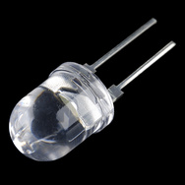
Super Bright LED - White 10mm COM-11118 RoHS Compliant
Description: Huge 10mm through hole LEDs. Mood-light an entire wall! Features:
- 3.0-3.4VDC Forward Voltage
- 80mA Forward Current
- 30 degree viewing angle
- 16,000-20,000 MCD output

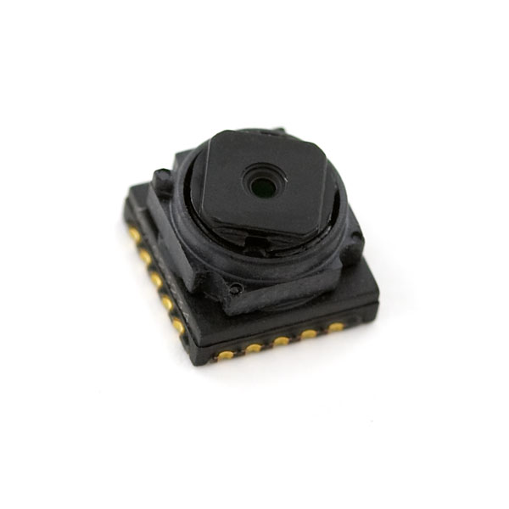
CMOS Camera - 640x480 SEN-08667
Description: The TCM8230MD is a high quality, very small 640x480 CMOS camera from Toshiba with the standard data+I2C interface. The nice thing is that we have a complete datasheet on this camera along with a good supplier. Features:
- Small size
- 2.8V Supply
- 30fps
- 640x480 pixels
- RGB color filter
- 1/6 inch optics included
- YUV or RGB output
- Auto shutter control (AES)
- Auto gain control (AGC)
- Auto white balance (AWB)
Dimensions: 6x6x4.5mm

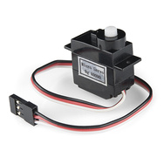
Servo - Generic (Sub-Micro Size) ROB-09065 RoHS Compliant
Description: Here is a simple, low-cost, high quality servo for all your mechatronic needs. This servo is very similar in size and specifications to the Hitec HS-55. This little guy is able to take in 6 volts and deliver 20.8 oz-in. of maximum torque at 0.10 sec/60°
This small servo comes with a standard 3 pin power and control cable, and all hardware listed below.
Note: This servo is rated for 180° rotation, but in actuality it only hits ~160°.
Features:
- Voltage: 4.8-6.0 Volts
- Torque: 16.6/20.8 oz-in. (4.8/6.0V)
- Speed: 0.15/0.10 sec/60° (4.8/6.0V)
- Rotation: ~160°
- Single Top Ball Bearing
- Nylon Gears
- 3-Pole Ferrite Motor
Includes:
- 1x Micro Size Servo
- 1x Single Arm Micro Horn
- 1x Double Arm Micro Horn
- 1x Four Point Micro Horn
- 1x Circle Micro Horn
- 2x 2x8mm Phillips Screw
Dimension:
- 31.8 x 11.7 x 29mm
- Wire Length: 160mm
Weight: 9g

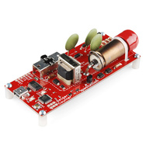
Geiger Counter SEN-11345 RoHS Compliant
Description: You talked, we listened, and we've revised our Geiger Counter board to address some of the most pressing concerns. This version features an improved voltage regulation circuit for the Geiger tube which has a much cleaner output. We've also modified the signal capture portion of the board so that it reads active high, allowing for more dependable counts that are less susceptible to fouling due to line capacitance. The new signal capture circuit also pushes the CPM limit to 100Hz!
This USB powered Geiger Counter is equipped with an ATMega328 that can be programmed in circuit using one of the programmers below. Simply plug the unit into USB (make sure you have FTDI drivers installed), open a terminal program to the correct COM port at 9600bps, and you will see random bits being generated from the random background radiation. Each bit generated (an ASCII byte 0 or 1) represents an actual event in the tube in real-time, so the output can be used to deduce CPM or what ever units you need. Here at SparkFun, on average, we get about 25 counts a minute. Want proof? Check out the live Geiger Counter feed from SparkFun headquarters. While you're at it, why not check out the random number generating Geiger counter tutorial?
Note: While the Geiger counter is powered and the switch is in the ON position, the board contains exposed high voltage components. In order to turn the unit off, you must flip the tube power switch to OFF while the USB cable is plugged in or while the board is still connected to your power supply. The reason being; when you move the switch into the OFF position, the high voltage lines are bled out through a resistor connected to ground, more information on this is in the tutorial. A project box or enclosure is suggested. Do not touch the end window of the Geiger tube and do not to touch any conductive region inside the area marked HIGH VOLTAGE when the Geiger tube is powered ON. An enclosure is not absolutely necessary, but if you choose not use an enclosure, remember to be extra careful with the end window and high voltage regions. The Geiger tube comes with a red boot to protect the end window during production, handling, and shipping. The boot should be removed if you need to detect alpha particles. However, you should still see activity from gamma and beta particles even with the boot on.
This product is controlled for export by the United States. Sending it to other countries may still be possible, but will require additional information prior to shipment.
Note: This product is for educational purposes and should not be directly relied upon for determinations regarding one's health or safety.
Dimensions: 4.15"x1.75"x1" (w/o standoffs) Features:
- 5V Logic
- Total Current 30mA
- LND712 Geiger Tube @ 560V
- ATMega328 Microcontroller
- FTDI USB Interface
- On Board Power and Status LEDs
- TTL (Active High) Output Pin from Tube

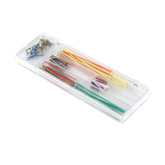
Jumper Wire Kit PRT-00124 RoHS Compliant
Description: This is a time saving kit of jumper wires - cut, stripped, and pre-bent for your prototyping pleasure. Included with this kit are 14 various lengths of 22AWG wire - 2, 5, 7, 10, 12, 15, 17, 20, 22, 25, 50, 75, 100, and 125mm - 10 pieces of each.

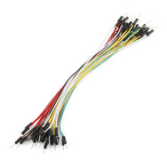
Jumper Wires Standard 7" M/M Pack of 30 PRT-11026 RoHS Compliant
Description: If you need to knock up a quick prototype there's nothing like having a pile of jumper wires to speed things up, and let's face it: sometimes you want quantity over quality. These are the same jumper wires that come with the SparkFun Inventor's Kit, they're less rugged than the premium jumper wires but they're great for bread-boarding, they're less expensive and we sell them in packs of 30! They may not hold up to year after year of abuse but they're a good value and we use them all the time here at SparkFun, both in classes and personal projects. Your pack of 30 jumper wires will be a random assortment of various colors.
Dimensions: 7" long

