Practicum 15-J Eccentric Motors
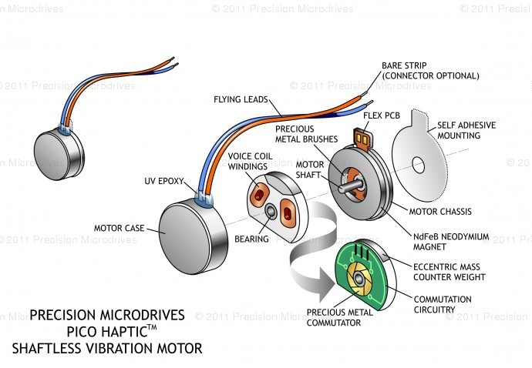
Goal: To make an eccentric motor vibrate through various frequencies for various lengths of time. And to gain skills in programming by building a circuit and adjusting Arduino code to perform the desired task.
Rules:
- Work in groups of 1 or 2. There are only 8 of you and there are 8 Arduinos and computers, so everyone could have their own…but collaboration is more likely to yield results.
- One person should be the electrical engineer and lead in building the circuit. Sketch the circuit in your journal.
- The other person should be the programmer and lead in writing the program.
- Get the base code from any source you want.
- You might want to start simple:
http://www.dummies.com/how-to/content/how-to-spin-a-dc-motor-with-the-arduino.html?cid=RSS_DUMMIES2_CONTENT
- Use this base code to create the code you are desiring.
- Adjust the code as necessary.
- Make the motor vibrate smoothly through a range of frequencies over a period of one minute, rest for 10 seconds, and then repeat.
- Once you are done, email your code (along with the answers to the questions below) back to me as a response to my email.
- Make an entry in your journal.
Issues and Questions:
- The first group to accomplish the task does not have to answer the questions.
- Which vibrating motor did you use? Describe it.
- Why does an eccentric motor vibrate when it spins?
- How do you determine/control the frequency of the vibration?
- What do you think the hardest part of our Arduino code will be?

