Practicum 16-J Using Eccentric Motors
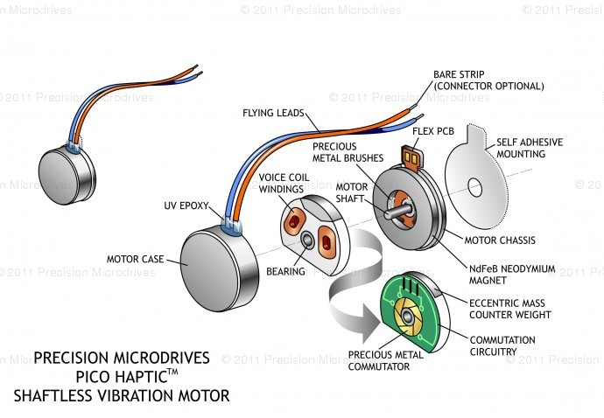
Goal: To make an eccentric motor vibrate a container of particles, through various frequencies, for various lengths of time. You want the particles to move around in the container, maybe even bounce slightly. And to gain skills in programming by building a circuit and adjusting Arduino code to perform the desired task.
Rules:
- Work in groups of 1 or 2.
- One person should be the electrical engineer and lead in building the circuit. Sketch the circuit in your journal.
- The other person should be the programmer and lead in writing the program.
- You can use the base code that I emailed you or start with the motor code that allows you to enter a motor speed into the serial window.
- Use this base code to create the code you are desiring.
- Adjust the code as necessary.
- Try to estimate at what frequency the particles moved or bounced the most.
- Narrow the frequency range, and try again.
- Pick a specific frequency that maximizes the movement of the particles.
- Make an entry in your journal. Email the answers to the questions to Fr. Reedy as a response to his code email.
Issues and Questions:
- Which vibrating motor did you use? Describe it.
- Did it make the particles move?
- Did it make them bounce?
- How did you determine/control the frequency of the vibration?
- What do you think our worst-case scenario is for this experiment?
- What will happen if this worst-case scenario occurs on the ISS?

