***TEST EQUIPMENT DATA PACKAGE***

***Kathy Duquesnay***

***Duchesne Academy of the Sacred Heart***

*Kathy.duquesnay@duchesne.org*

*713-468-8211ext. 286*

*10202 Memorial Dr.*

*Houston, TX 77024*

***The Effects of Microgravity and Light Wavelength on Plant Growth***

*TEDP Completion Date: Feb. 2, 2014*

*Version 8 April, 28, 2015*

***IMPORTANT THINGS TO NOTE:***

***Avoid permanent magnets if possible***

***Avoid Shatterable materials if possible (e.g. class) However there are ways to secure these items, just be sure Mentor and NanoRacks are aware so that they can be packaged appropriately.***

***Avoid pressure vessels***

***Avoid substances with toxicity higher than 2 on MSDS’s***

***CHANGE RECORD Several more corrections since the Numerous changes in Version # 7- many things deleted additions highlighted in yellow***

|  |  |  |  |  |  |  |  |
| --- | --- | --- | --- | --- | --- | --- | --- |
| ***Doc. Version*** | | ***Date*** | ***Description*** | ***Page No.*** | | | ***Change Authority*** |
| # 2 | | 3/12/14 | Updated Materials list | 10-11 | | |  |
| # 2 | | 3/12/14 | Minor changes in experiment design | 7 | | |  |
| # 2 | | 3/12/14 | Minor addition in “D” | 8 | | |  |
| # 3 | | 3/18/14 | Off-loading description | 65 | | |  |
| # 3 | | 3/18/14 | Solder MSDS added | 59 | | |  |
| #3 | | 3/18/14 | Super waterproof/breathable-Tex added to materials list | 12 | | |  |
| #3 | | 3/1814 | Increased the number of photographs in experiment design | 7 | | |  |
| # 3 | | 3/18/14 | Functional block diagram with current draws | 14 | | |  |
| #4 | | 3/20/14 | Information on the real time clock, added to materials list, schematics, and block diagram | 12,16,17,& 18 | | |  |
| # 4 | | 3/20/14 | Increased number of photos taken | 8 | | |  |
| # 4 | | 3/20/14 | Changed the font size of one of the MSDS sheets which changed the numbering of the last few pages | 62-64 | | |  |
| # 4 | | 3/20/14 | Added and replaced a picture of the ardulab | 13 | |  | |
| # 4 | | 3/20/14 | Updated the mass | 12 | |  | |
| # 5 | | 3/24/14 | Updated mass of many items already listed on materials list | 2, 9-12 | |  | |
| # 5 | | 3/24/14 | Flight date change | 2 | |  | |
| #6 | | 4/4/14 | Changed down link to once on day 29 | 8 &62 | |  | |
| #7 | 4/20/15 | | Numerous changes – all highlighted |  |  | | |
| # 7 | 4/20/15 | | Different cameras & lenses | p. 7 & 8 |  | | |
| # 7 | 4/20/15 | | Added SD card which was left off all previous versions | p. 11 |  | | |
| # 7 & #8 | 4/20/15 | | Removed all references to Ardulab and replaced with Nanolab |  |  | | |
| ***# 7*** | 4/20/15 | | Removed real time clock and battery |  |  | | |
| ***#8*** | 4/28/15 | | Reduced the number of photographs from one every 30 minutes to one every 6 hours/ 3 times daily per side (6 pictures/day total) |  |  | | |
| ***#7*** | 4/20/15 | | Changed the mass slightly | p. 13 |  | | |
| ***#7*** | 4/20/15 | | Added information on the new cameras and lenses – removed reference to cameras from previous versions | p. 16 & 17 |  | | |
| ***#8*** | 4/28/15 | | Reduced number to times for downlinking data | p. 55 |  | | |
| ***#7*** | 4/20/15 | | ABS divider will be 3d printed instead of cut from a larger piece | p.12 |  | | |
| ***#8*** | 4/28 | | Orientation requirement for transportation to and from the ISS | p. 8 |  | | |
|  |  | |  |  |  | | |
|  |  | |  |  |  | | |

***QUICK REFERENCE DATA SHEET***

*Team Name: Duchesne Academy 8th Grade*

*Principal Investigator: Kathy Duquesnay*

*Contact Information: kathy.duquesnay@duchesne.org*

*Experiment Title: The Effects of Microgravity and Light Wavelength on Plant Growth*

*Work Breakdown Structure (WBS):*

*Flight Date(s): June 19, 2015*

*Overall Assembly Weight (lbs): 2.02 lbs*

*Assembly Dimensions (L x W x H): 15cm x 10.16 cm x 10.16 cm*

*Equipment Orientation Requests in reference to NanoRack: only matters while in transit to ISS*

*Proposed Mounting to NanoRack: Just the USB connections*

*Does Experiment need to be located next to fan on NanoRack: (Yes or No) No.*

*Power Requirement (Voltage 9and Current Required): USB Connection*

*Camera or Video Requested? (Yes or No): No*

***TABLE OF CONTENTS***

*Section___________________________________________________________________Page Number*

*Change Page       2*

*Quick Reference Sheet                   3*

*Basic Mission Objective     5*

*Experiment Background 5*

*Experiment Description 7*

*Operational Scenario 8*

*Equipment Description 8*

*Electrical Analysis 14*

*Institutional Review Board Information 19*

*Hazard Analysis 19*

*Tool Requirements 19*

*Photo Requirements 19*

*Hazardous Material 19*

*Material Safety Data Sheets (MSDS) 19*

*Experimental Procedures Documentation 62*

*Bibliography 63*

*Deviations/Exceptions/Waivers 64*

***BASIC MISSION OBJECTIVE:***

*Technology demonstration, research, Proof of concept?*

This experiment will test the effect of combinations of red and blue wavelengths of electromagnetic radiation on pea shoots, a small fast growing edible plant. We can start these plants from seeds and they will be placed in a 10.16 cm x 10.16cm x 15 cm Nanolab and grown in a microgravity environment.

This experiment will be important so that plants with high nutrition can be effectively and rapidly grown on the ISS and on future long duration flight. We propose to identify the combination red and blue LEDs that will induce the most rapid growth.

***EXPERIMENT BACKGROUND***

*Why is this experiment relevant?  What questions will it answer? Include NASA supporting org. and programs and research history.*

The selection process for a nutritional, rapidly growing plant that could be easily grown from seeds led us to three vegetables commonly eaten as shoots. In their early stages of life, peas, popcorn shoots, and bamboo could be used as test subjects to observe the speed of growth under different wavelengths of light. Pea shoots contain high amounts of Vitamin A, B, C, E, calcium, chlorophyll, iron, magnesium, niacin, phosphorus, potassium, amino acids, and protein up to 25%. In additional to their nutritional values, they are also low in sodium, fat, and sugar. They can be harvested after only two to four weeks of growth, and have a seed shelf life of four to five years. Popcorn shoots also contain Vitamin A, B, C, E, calcium, chlorophyll, iron, lecithin, magnesium, pantothenic acid, phosphorus, potassium, trace elements, and around 30% protein. However, popcorn seeds only take between eight to twelve days to sprout. In addition to pea and popcorn shoots, bamboo shoots are also highly beneficial. Studies show that bamboo can prevent the production of cancerous cells, improve appetite and digestion, aid weight loss, and treat hypertension and hyperglycemia. The main nutrients include high levels of protein, amino acids, healthy fats and sugars, salt, and water contents.

We are planning to use a combination of red and blue LED lights. According to our research, a mixture of red and blue lights provides the optimal wavelength to induce favorable plant growth.

Professor Allen Barker at University of Massachusetts Amherst stated that 450 and 650 nanometers are required for photosynthesis, and red light has wavelengths between 622 and 780 nm. Blue light has between 455 to 492 nm, and violet light has between 390 and 455 nm. Also between 650 and 730 nm wavelengths allow the plant to flower by influencing the phytochrome plant pigment.

NASA has used white, green, and red lights in the past; this is one of the reasons we have decided on these colors. Red LED lights have been proven by NASA to cause the plants to have a “higher concentration of anthocyanin, an antioxidant that can combat some of the effects of cosmic radiation” (LED Lights Used in Plant Growth Experiments for Deep Space Missions). Another NASA study concluded that green lights are also beneficial to plants. NASA believes the light is important because of the positive effects, like an increase of antioxidants, can have on the plants.

A space experiment called VEGGIE, short for plant growing system about the size of a microwave oven, to be sent onto the ISS on Dec. 9 2013. The experiment called for red and blue LED lights for photosynthesis to take place and to make experiments. LED lights are being used because of their long lifetime.

From October 2009 to September 2010, scientists grew a garden of thale cress on ISS in an experiment called ADSVAC, which tested the Advanced Astroculture Plant Growth Chamber.  Scientists genetically modified these plants to under how stress in a zero gravity environment was affecting the plants. When they genetically modified the plants, it allowed them to glow when they were unhappy. This was helpful because it meant they could examine the plant without dissecting it.

        Seeds in space followed the same sprouting pattern and growth stages as the plants here on Earth. Many scientist were concerned that the roots would grow incorrectly because it was thought that gravity had an effect on the downward formation of the roots. After NASA had conducted a successful experiment on the international space station, it is known that gravity is not necessary to growing plants.

In 2010, the ISS was sent plants called *Arabidopsis thaliana* or Thale Cress. These plants were used to study how plant roots developed in a weightless environment. These plants were grown on a nutrient-rich gel in clear petri plates. These plants showed familiar root growth patterns where roots slant progressively as they branch out. Researchers have always thought that direction of growth was the result of gravity's effects on root tip growth. Others think that in microgravity, other factors take over that enable the plant to direct its roots away from the seed and light-seeking shoot. Those factors could include moisture, nutrients, and light.

A study was done at the University of Wisconsin and at Kennedy Space center growing wheat plants with only red lights. The plants were dying, thin, and very "pale" because of the loss of chlorophyll.  Blue fluorescent lights repaired most of the problems caused by the red LEDS.  In the September of 2012 NASA ran and experiment monitoring the growth of radish plants versus red leafed lettuce and in different types of lights and light levels. A chlorophyll meter was used to measure the amount of chlorophyll in a plant. Afterwards, the plants were frozen in liquid nitrogen and were pulverized into a new powdery form. The powder would be used to run a new test in which the amount of stored energy in the plant tissue would be measured. The plants were grown in red, blue, white, and green LED lights. Some lights increase nutrients and antioxidant. The lettuce and radishes showed darker red color under the red and blue LED lights, some nutrients found in red leafed lettuce thrived in the red light. Some of these nutrients fight cosmic radiation. Ongoing experiments are currently further investigating the topic.

***EXPERIMENT DESCRIPTION***

*Brief explanation of experiment. Include sketches or AUTOCAD ipt files*

If pea shoot plants, *Pisurn sativum*, are exposed to microgravity and different combinations of red and blue light wavelengths, then the plants will demonstrate the most growth on the side with the ratio of three red to one blue super-bright LED light, because red light has the longest wavelength, is bent the least, and moves the slowest, so the plant would be able to absorb the light more effectively.  The other side will have three blue LEDs and one red LED.  The four LEDs will be in clustered spread out on a side opposite the seeds. The seeds, after sterilization with a 5% bleach solution and rinsing in sterile water, will be placed on top of Phytoblend agar with nutrients. This will supply the necessary moisture and growth media required for the pea shoots. Every ~~30 minutes~~ 6 hours ( 3 pictures per side per day)while the lights are on, a photo will be taken. This will allow us to observe and measure length and growth and even create a time lapse movie of the plant growth.  We will measure the growth of the plants on each side by viewing the photographs. The progress of the plant growth will also be compared to a grid attached to the sides of the ~~Ardulab~~ divider. The grid will be marked off in 0.2 centimeter increments. The LEDs and the cameras will be attached to and controlled by the ~~arduino mega microprocessor built into the 1U Ardulab~~ Nesi+ attached to the end of a 1 ½ U Nanolab with several holes drilled for air flow( note the holes will be covered by a Gore-tex like fabric). After the ~~ardulab~~ Nanolab returns to Earth the mineral content of the plants on each side will be analyzed and compared.

***OPERATIONAL SCENARIO***

***A.****High Level Summary of Payload Operations, general overview*

The ~~Ardulab~~ Nanolab should be at +4 degrees Celsius until it reaches the ISS. It then needs to be destowed and be plugged into the nanoracks immediately after the destowage. It should run for ~~thirty~~ twenty four days and once destowed, at the end of the ~~30~~ 24 days it should be kept at +4 degrees C until returned to Earth on Space ~~X5~~ X8 if possible.

***B.****Specific constraints for payload (ie. Activation requirements, temperature requirements to/on/from ISS, orientation requirements during transport to ISS)*

The ~~Ardulab~~ Nanolab should be at +4 degrees Celsius until it reaches the ISS. It then needs to be destowed and be plugged into the nanoracks immediately after the destowage. It should run for ~~thirty~~ twenty four days and once destowed, at the end of the ~~30~~ 24 days it should be kept at +4 degrees C until returned to Earth on Space ~~X5~~ X8 if possible.

The orientation requirements during transport to the ISS are as follows: Orient the Nanolab with the NESI+ Board at the top of the Nanolab

We would like the same orientation when it is returned to Earth.



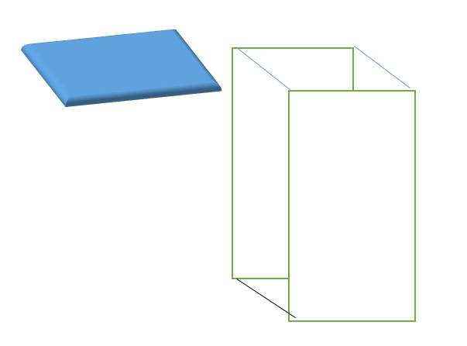



***C.****How long does the experiment need to operate for? Does the experiment require any crew interaction?*

The experiment will operate for the full ~~thirty~~  twenty-four days in flight. It will not require any crew interaction.

***D.****Will payload need to be returned or disposed of once ops complete?*

The payload will need to be returned on Space X 8 so that we can make additional observations and recover the SD card. The mineral take up of the plants will be analyzed and compared for additional quantitative data.

***E.****What kind of data needs to be collected during the mission and will ground operations be required (ie. Downlinking to NanoRacks mission control?)*

6 photographs will be in each 24 hour period (3 per camera/per side), 180 photographs in all. These will be saved on the SD card that Nanoracks and downlinked before removing from the Nanoracks USB connection

***EQUIPMENT DESCRIPTION***

*A.     Ground-Based and Flight Equipment (if there is no difference just reference the flight Equipment.  Please make excel spreadsheet for all categories of the equipment.)*

There is no difference in the equipment.

1. *Pictures- See table below*

*b.      Descriptions of each piece of equipment*-

All of the equipment will be placed inside of the 1 ½ U nanolab. See spreadsheet below for the equipment within the nanolab and the nanolab itself.

|  |  |  |  |  |  |  |  |
| --- | --- | --- | --- | --- | --- | --- | --- |
| Item | part no. | # | description | dimensions | wt |  | picture |
| Camera |  | 2 | Electronics 123 C329-UART board camera JEG compression VGA camera module | 20mmx28 | 5.6g | |  | | --- | | http://ecx.images-amazon.com/images/I/61QfBOTHO9L._SL1200_.jpg | |
| lens |  | 2 | L36IR lens & holder with screws for C329 camera | mm | 4.5 g | http://www.electronics123.com/website/image/product.template/4843_bc2ef77/image |
| Red Superbright LEDs | COM-00528 | 4 | Sparkfun LEDs to provide light for the plants to grow 9,000mcd brightness | 5 mm | .3g | https://dlnmh9ip6v2uc.cloudfront.net/images/products/5/2/8/08285-01.jpg | https://dlnmh9ip6v2uc.cloudfront.net/images/products/5/2/8/08285-01.jpg |
| Blue super bright LEDs | COM-00529 | 4 | Standard size - T1 3/4 5mm 2.4 V forward drop Max current 20mA | 5mm | .3g | https://dlnmh9ip6v2uc.cloudfront.net/images/products/5/2/8/08285-01.jpg |  | |  |
| jumper wires | PRT-08431 | 13 | Sparkfun Jumper Wires Premium 6" M/M | 50 in total | .7 | https://dlnmh9ip6v2uc.cloudfront.net/images/products/8/4/3/1/JumperWire-Male-01-L_i_ma.jpg | https://dlnmh9ip6v2uc.cloudfront.net/images/products/8/4/3/1/JumperWire-Male-01-L_i_ma.jpg |
| solder |  |  | solder with a 60 Sn/40 Pb for attaching wires, all be covered with shrink wrap insulation |  | 2g |  |
| resistors |  | 8 | 100 Ω, 120 Ω, 220 Ω, 3300 Ω, 1000 Ω (2) , 1500 Ω ( 2) |  | .3 |  |
|  |  |  |  |  |  |  | C:\Users\Kathy & Mark\AppData\Local\Temp\yblotsog.tmp\photo.JPGhttp://www.caissonlabs.com/use_images/product_images/A037-2.5KG.jpghttps://encrypted-tbn1.gstatic.com/shopping?q=tbn:ANd9GcSS77CpCqYiKOSgdvfBbjd4WMT-MNj5u-O0FhAfwq2WZU9wOzHB33wY0sxUPpLFp4eApydKH9ca&usqp=CAE |
| Phytoblend agar w/nutrients |  |  | Solid gel growth media for the seeds | 190 mL after mixing  Note: this is a slight increase to allow for maximum growth | 190g | http://www.caissonlabs.com/use_images/product_images/A037-2.5KG.jpg |
| 3m mounting tape |  | 2 | Natural rubber adhesive to hold the cameras in place and to hold the seed containers in place | 20 mm x 28mm x 5mll | 2.3 | https://encrypted-tbn1.gstatic.com/shopping?q=tbn:ANd9GcSS77CpCqYiKOSgdvfBbjd4WMT-MNj5u-O0FhAfwq2WZU9wOzHB33wY0sxUPpLFp4eApydKH9ca&usqp=CAE |
|  |  | 2 |  |  |  |  | 10 in. x 8 in. Polycarbonate Sheet |
| Krazyglue All Purpose |  |  | Permanent glue to attach the Super Water proof /breathable-Tex fabric over the air exchange holes |  | 2 g | http://www.krazyglue.com/images/products/catalog/KG866.gif |
| pea seeds, *Pisurn sativum* |  | 10 | Quick growing food source and the plant that will be observed | Note: this is also a slight increase | .43g total | C:\Users\Kathy & Mark\AppData\Local\Temp\3fd5tqkw.tmp\photo.JPG |
|  |  |  |  |  |  |  |
|  |  |  |  |  |  |  | 02-911-870   |  | | --- | |  | |
| Acrylonitrile Butadiene Styrene (ABS  3-D printed boxes |  | 2 | Containers to hold the Phytoblend agar and the seed | 8 cm x 4 cm x 3 cm to hold 85 mL each | 25g | C:\Users\kathy.duquesnay\AppData\Local\Microsoft\Windows\Temporary Internet Files\Content.Outlook\X2ULAN71\photo 3.JPG | |  | | --- | |  | |
| [MicroSD Card with Adapter - 8GB](https://www.sparkfun.com/products/11609) | COM-11609 | 1 | SD card to record the data |  |  | Product Image | |  | | --- | |  | |



|  |  |  |  |  |  |  |  |  |  |  |  |
| --- | --- | --- | --- | --- | --- | --- | --- | --- | --- | --- | --- |
| laminated graph paper |  | | 3 | 2 mm grid Graph paper covered with standard laminating film (melts at 260° to 290° F) These will be placed on 2 sides of the ABS divider to judge plant growth- will attach using Krazy Glue or double sided tape | 3.5" x 3.5 | 2.2 | | |  | | --- | |  | | | |
| double sided tape to mount the laminated paper | | Cat. 137 | 18 | Scotch® Double Sided 136 Office Tape is coated with permanent adhesive on both sides. A no-mess alternative to glue for light duty attaching and mounting tasks. This tape has no liner to deal with, is long-aging and won't dry out or yellow. | | | 1/2" x 1/2" pieces | | 2 g | |  | | --- | | Scotch (R) Double Sided Tape 237 | | |

|  |  |  |  |  |  |  |  |
| --- | --- | --- | --- | --- | --- | --- | --- |
| 2 ply Super Waterproof/breathable-Tex fabric |  | 4 | 2-Ply Colors Waterproof, breathable and windproof. The two-ply has a face fabric and a micro porous Teflon membrane. It is recommended that 2-ply be lined, to protect the membrane. This will be superglued around the edges to cover the air exchange holes. | 2" x 1/2" pieces | 10 g | |  | | --- | | Outdoor Furniture Fabric | |

|  |  |  |  |  |  |  |  |  |  |
| --- | --- | --- | --- | --- | --- | --- | --- | --- | --- |
|  | |  | | 1 |  |  | |  |  |
|  |  | |  | |  | |  |  |
| Nano Lab & Nesi+ board |  | | 1 | | Texas A & M microcontroller and 1½ U Nanolab | | 557g | C:\Users\kathy.duquesnay\AppData\Local\Microsoft\Windows\Temporary Internet Files\Content.Outlook\X2ULAN71\NESI+2A.PNG |
| Acrylonitrile Butadiene Styrene (ABS  3-D printed divider |  | |  | | 3D printed ABS inset to hold cameras, LEDs and the cameras | | 55g | C:\Users\kathy.duquesnay\AppData\Local\Microsoft\Windows\Temporary Internet Files\Content.Outlook\X2ULAN71\photo.JPG |

*c.       Dimensions-*

15 cm x 10.16 cm x 10.16 cm

*d.      Mass*-

about 910 g (2 lbs to 34 oz)

*e.       Hardware Class (different classes based on toxicity of material)*

Class 1, secure hardware

*B.     Equipment Layout for Take-off, in Flight, and Landing (some of this information provided by NanoRacks.  Equipment may be stowed in flight stowage bag during liftoff and landing.  Show how the Nanolab should be interfacing the NanoRack with orientation.  Diagrams are helpful.*

The Nanolab, the Nesi+ with the USB connection MUST be on the top. This should be the orientation for both take-off and landing.



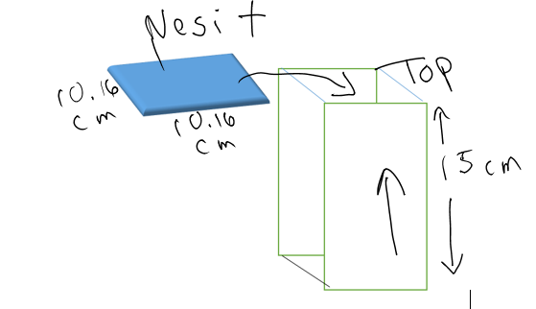



*C.     Special Handling/Special Hazards/Special Requirements*

*Crew handling during mission?  Will crew be handling toxic materials?*

No special handling needed.  The crew will not be handling toxic materials

*D.      Bio/Chemical Contents :*

*Complete JSC form 27472 if applicable and provide MSDS .  Avoid substances with toxicity higher than a 2 on MSDS form.*

See MSDS Sheets below.

*E.      Inventory of In-flight Items*

*Any extra materials that will need to be stowed outside of the Nanolab? If you have items that are going to be operated by the crew outside of the module provide a sketch or enough details to create a drawing.  Photographs are great if available.*

Nothing will be stowed outside of the Nanolab

***ELECTRICAL ANALYSIS***

1. *Schematic drawing with all current and voltage draws*

New wiring diagram for Nanolab & Nesi+

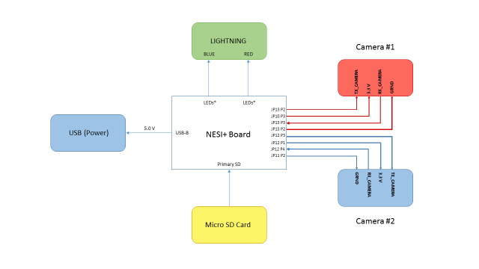

New wiring diagram for Nanolab & Nesi+ The lights will be in a slightly different position than show but the wiring will be the same.

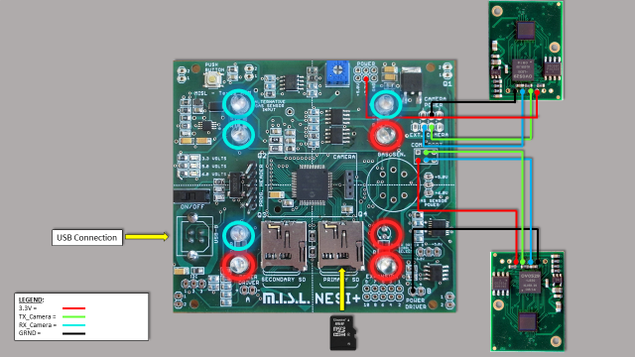

Note there will not be a real time clock

*B.     Load Table Not updated yet but should be similar*

|  |  |  |  |  |  |  |  |
| --- | --- | --- | --- | --- | --- | --- | --- |
| **Trail** | **3 Blue LED (Amps)** | **3 Red LED (Amps)** | **1 Blue LED (Amps)** | **1 Red LED (Amps)** | **Cam.1 (Amps)** | **Cam.2 (Amps)** | **SD (Amps)** |
| **1** | **0.088** | **0.083** | **0.075** | **0.08** | **0.08** | **0.09** | **0.08** |
| **2** | **0.095** | **0.095** | **0.093** | **0.099** | **0.09** | **0.089** | **0.07** |
| **3** | **0.1** | **0.097** | **0.097** | **0.101** | **0.1** | **0.095** | **0.077** |
| **4** | **0.096** | **0.097** | **0.099** | **0.1** | **0.09** | **0.093** | **0.081** |
| **Avg Amp Draw** | **0.09475** | **0.093** | **0.091** | **0.095** | **0.09** | **0.09175** | **0.077** |
|  |  |  |  |  |  |  |  |

|  |  |  |
| --- | --- | --- |
| **ArduLab** |  |  |
| **Trails** | **Nothing Plugged In (Min)** | **Nothing Plugged In (Max)** |
| **1** | **0.077** | **0.1** |
| **2** | **0.088** | **0.109** |
| **3** | **0.095** | **0.112** |
| **4** | **0.093** | **0.113** |
| **Avg Amp Draw** | **0.08825** | **0.1085** |

*C.     Stored Energy*

None

*D.     Electrical Kill Switch* *How will experiment be turned off in event of an emergency?*

Just remove the Nanolab from its Nanoracks USB connection.

*E.      Loss of Electrical Power (Fail-Safe)*

The lights and cameras will not operate without the USB connection.

*F.       TRY TO DESIGN without Batteries and just use the NanoRacks platform with USB power.  If Batteries cannot be avoided, please include the following information and specifications:*

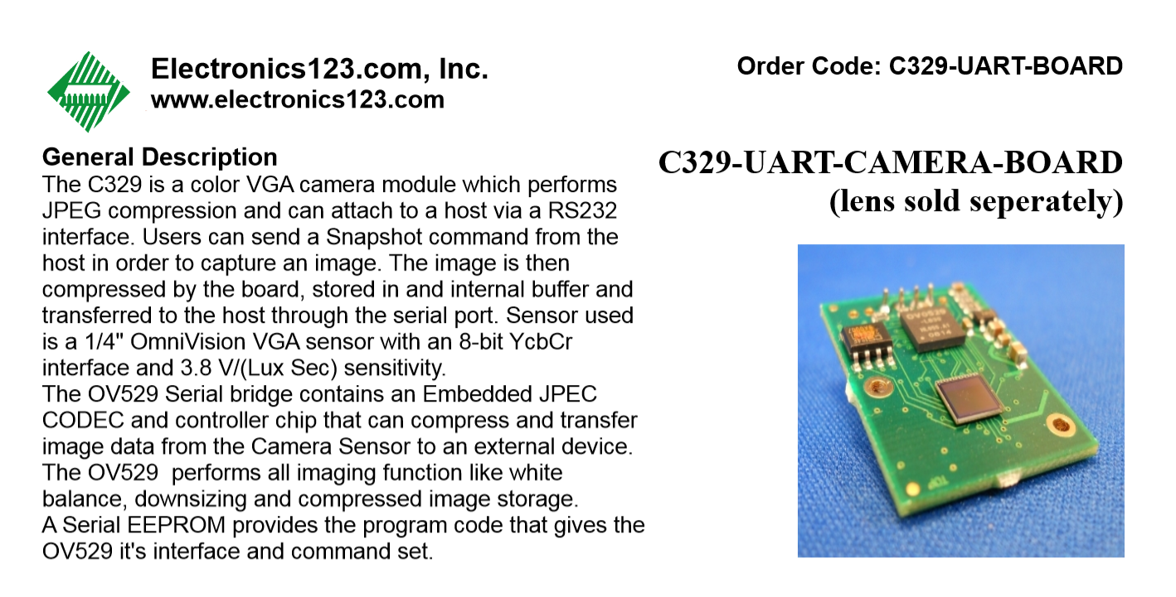 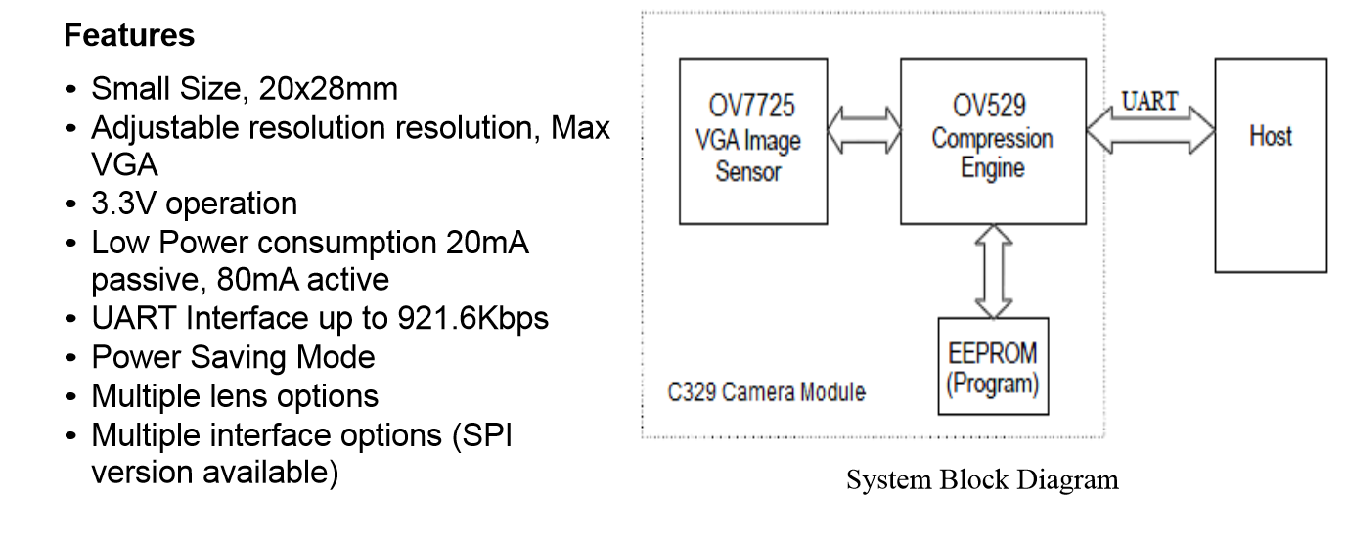. 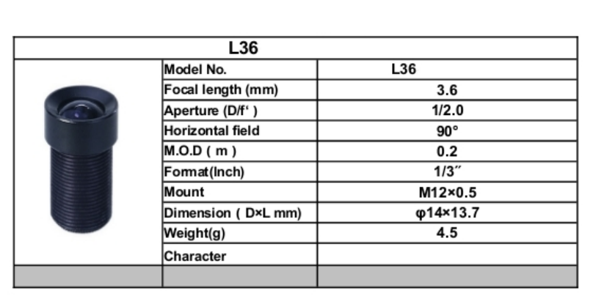

No heater involved.

***INSTITUTIONAL REVIEW BOARD***

*Only for human or vertebrate animal test subjects.*

***HAZARD ANALYSIS***

***A.****General Hazard Identification Checklist*

[*http://jsc-aircraft-ops.jsc.nasa.gov/Reduced_Gravity/docs/NS-STO-CH01.pdf*](http://jsc-aircraft-ops.jsc.nasa.gov/Reduced_Gravity/docs/NS-STO-CH01.pdf)

Hazard- mold growth on the Phytoblend agar. We will sterilize the seeds and the agar will be totally contained inside the Ardulab.

***TOOL REQUIREMENTS***

*A.     Additional Tools that will be required in flight for crew monitoring of the project.*

None needed

***PHOTO REQUIREMENTS***

*A.     Camera/Video required?  How often during mission required?*

None needed the cameras are inside the ardulab.

*B.     Downlink Requirements*

The SD card needs to be read and downlinked to CASIS (not sure who gets the downlink) by Nanoracks just before unplugging and destowing the data ~~should be downlinked~~ ~~at the same time daily then downlinked by Infinity Aerospace 3 times a week.~~

*C.     Still/Video Photographer Special Requests*

None needed the cameras are inside the Nanolab ~~ardulab~~.

***HAZARDOUS MATERIAL***

*List any hazardous material being used and it hazard number associated with it.  Include MSDS sheet for that material in section below.*



***MATERIAL SAFETY DATA SHEETS (MSDS)***

*Included are MSDS sheets for the following:*

Phytoblend agar, ~~Lexan plastic~~, Krazy glue, ABS (Acrylonitrile Butadiene Styrene), and solder.

***Material Safety Data Sheet***

I Material & Company Identification

Product Name: **Phytoblend**

Catalog Number: PTP01

Company: Caisson Laboratories

Address: 1740 Research Park Way, North Logan, UT 84341

Telephone: 435.755.7615   Fax: 435.755.7617

Emergency Contact: CHEMTREC 800.424.9300 (703.527.3887)

II Composition / Information on Ingredients

General Information:

Component:  CAS#: 9002-18-0

% by Weight:

III Hazards Identification

Overview: Health Rating: 0 - None

Flammability Rating: 1 - Slight

Reactivity Rating: 0 - None

Route of Exposure

Oral: Not expected to be a health hazard.

Inhalation: If inhaled, move to fresh air. If breathing becomes difficult, call a physician.

Dermal: Not expected to be a health hazard.

Eye: In case of contact with eyes, flush with copious amounts of water for at least 15 minutes. Assure adequate flushing by

separating the eyelids with fingers. Call a physician.

Suitable Extinguishing Media: Use any means suitable for extinguishing surrounding fire.

Special Protective Equipment for fire fighters: Use protective clothing and breathing equipment appropriate for the surrounding fire.

Additional Information: Not considered to be a fire hazard. Not considered to be an explosion hazard.

VI Accidental Release Measures

General Information: Ventilate area of leak or spill. Wear appropriate personal protective equipment. Spills: Sweep up and containerize

for reclamation or disposal. Vacuuming or wet sweeping may be used to avoid dust dispersal.

VII Handling and Storage

Handling:

Storage: General storage, keep in a tightly closed container, stored in a cool, dry, ventilated area

Temperature: 15 to 30° C   Light Sensitive: False

Incompatibles: Strong oxidizers.

Hazardous Decomposition Products: Carbon dioxide and carbon monoxide may form when heated to decomposition.

Stable under ordinary conditions of use and storage.

XI Toxicological Information

General Information:

Acute Toxicity: Complete toxicological properties have yet to be determined.

Chronic Toxicity: Complete toxicological properties have yet to be determined.

Carcinogenicity: Investigated as a tumorigen.

OSHA Permissible Exposure Limits: No exposure limits established by OSHA or ACGIH

XII Ecological Information

General Information:

XIII Disposal Considerations

General Information:

Disposal of Product: Observe all federal, state and local environmental regulations.

Disposal of Packaging: Rinse and dispose according to federal, state and local environmental regulations.

Page 3 of 4

Material Safety Data Sheet

XIV Transport Information

Proper Shipping Name: CHEMICALS, N.O.S (NON-REGULATED)

XV Regulatory Information

General Information:

TSCA:

SARA 313:

XVI Other Information

General Information: The above information is believed to be correct but does not purport to be all inclusive and shall be used only as a guide. Caisson Laboratories, Inc. Shall not be held liable for any damage resulting from handling or from contact with the above product.

**Material Safety Data Sheet**

**1. Chemical Product and Company Identification**

DESCRIPTION: KRAZY GLUE ALL PURPOSE

PRODUCT TYPE: CYANOACRYLATE ADHESIVE

APPLICATION: KG-583, KG-585, KG-517

•         **Manufacturer/Supplier Information**

MSDS Prepared by:

Elmer's Products, Inc. Emergency Phone Number

1 Easton Oval Poison Control Center

Columbus, OH 43219 888-516-2502

For additional health, safety or regulatory information, call 888-435-6377

Call 1-800-848-9400 to place an order or request additional MSDSs.

**2. Composition, Information on Ingredients**

The ingredients listed below have been associated with one or more

immediate and/or delayed(*) health hazards. Risk of damage and effects

depends upon duration and level of exposure. BEFORE USING, HANDLING, OR

EXPOSURE TO THESE INGREDIENTS, READ AND UNDERSTAND THE MSDS.

% by weight

7085-85-0 Ethyl 2-Cyanoacrylate

**3. Hazards Identification**

**3.1 Emergency Overview**

Appearance Colorless liquid

Odor Irritating

CAUTION!

COMBUSTIBLE

May become unstable at high temperatures or may react with water.

May be harmful if inhaled. May cause irritation of nose, throat and

lungs.

Bonds skin instantly. Causes skin irritation.

Bonds eyelids instantly. Causes eye irritation.

•         **HMIS Rating**

HEALTH = 2 (moderate)

FLAMMABILITY = 2 (moderate)

REACTIVITY = 1 (slight)

**3.2 Potential Health Effects**

•         **Immediate Hazards**

INGESTION: No hazards known to company.

INHALATION: May be harmful if inhaled. Liquid or vapor may cause

irritation of nose, throat and lungs.

SKIN: Bonds skin instantly. Causes irritation.

EYES: Bonds eyelids instantly. Causes irritation.

•         **Delayed Hazards**

None of the components present in this product at concentrations equal

to or greater than 0.1% have been listed by NTP, classified by IARC,

nor regulated by OSHA as a carcinogen.

**4. First Aid Measures**

INGESTION: If accidentally swallowed, dilute by drinking large

quantities of water. Immediately contact poison control

center or hospital emergency room for any other

additional treatment directions.

INHALATION: If inhaled, remove to fresh air. If not breathing,

give artificial respiration, preferably mouth-to-mouth.

Call a physician.

SKIN: If skin bonding occurs, soak in nail polish remover

or acetone and carefully peel or roll skin apart (do not

pull).

EYES: If eye contact occurs, hold eyelid open and rinse

thoroughly but gently with only water for 15 minutes and

GET MEDICAL ATTENTION. Do not use any solvents to

flush the eye and its surroundings. Liquid glue will

sting eye temporarily. Solidified glue may irritate eye

like a grain of sand and should be treated by an eye

doctor.

**5. Fire Fighting Measures**

Autoignition Temperature 485 deg C

Upper/Lower Flammable Limits Not available

Up/Lower Explosive Limits, % by Vol Not available

Flash Point 83 deg C (CC)

COMBUSTIBLE.

Keep away from heat and flame.

In case of fire, use water spray, dry chemical, foam or CO2. Use

water to keep fire-exposed containers cool.

**6. Accidental Release Measures**

Eliminate all ignition sources. Soak up with absorbent material and

remove to a chemical disposal area. Prevent entry into natural bodies

of water.

**7. Handling and Storage**

**7.1 Handling**

Handle in accordance with good industrial hygiene and safety

practices. These practices include avoiding unnecessary exposure

and removal of the material from eyes, skin and clothing.

Wash thoroughly after handling. Always use appropriate Personal

Protective Equipment (PPE).

INHALATION: Avoid breathing vapor. Use with adequate

ventilation.

SKIN: Avoid contact with skin and clothing.

EYES: Avoid contact with eyes.

**7.2 Storage**

Keep away from amines.

Store in cool, dry area away from sun and heat.

Keep containers tightly closed.

Exposure to small amounts of moisture, even moisture in air, causes

polymerization and renders the product unusable.

Keep away from heat, sparks, flame and other ignition sources.

**8. Exposure Controls/Personal Protection**

**8.1 Exposure Controls**

ENGINEERING CONTROLS: The following exposure control techniques maybe used to effectively minimize employee exposure: local exhaust

ventilation, enclosed system design, process isolation and remote

control in combination with appropriate use of personal protective

equipment and prudent work practices. These techniques may not

necessarily address all issues pertaining to your operations. We,

therefore, recommend that you consult with experts of your choice to

determine whether or not your programs are adequate.

If airborne contaminants are generated when the material is heated or

handled, sufficient ventilation in volume and air flow patterns should

be provided to keep air contaminant concentration levels below

acceptable criteria.

**8.2 Personal Protection**

Use goggles if contact is likely. Wear impervious gloves as required to prevent skin contact.

**8.3 Exposure Guidelines**

Ethyl 2-Cyanoacrylate 7085-85-0

ACGIH TLV: 0.2 ppm (1 mg/m³) TWA

OSHA PEL: NONE ESTABLISHED

**9. Physical and Chemical Properties**

Percent Volatiles Not determined

pH @ 25 C Not available

Specific Gravity 1.05

Appearance Colorless liquid

Autoignition Temperature 485 deg C

Boiling Point 62 deg C (5 mm Hg)

Vapor Density (Air=1) > 1

Vapor Pressure, mm Hg @ 20 C 0.13 (@ 20 deg C)

Evaporation Rate (Butyl Acetate=1) < 1

Upper/Lower Flammable Limits Not available

Up/Lower Explosive Limits, % by Vol Not available

Flash Point 83 deg C (CC)

Freezing Point < -20 deg C

Odor Irritating

Odor Threshold, ppm Not available

Solubility in Water Negligible

Coefficient of Water/Oil Distrib. Not applicable

**10. Stability and Reactivity**

Normally stable, but may become unstable at high temperatures or may react with water.

•         **Conditions to Avoid:**

Exposure to heat, flame and incompatibles.

•         **Incompatibilities:**

Water, alcohols, amines, bases and direct UV.

•         **Decomposition products may include:**

Oxides of carbon.

•         **Hazardous polymerization:**

Will not occur.

•         **Other Hazards:**

None known to company.

**11. Toxicological Information**

See Section 3 Hazards Identification information.

Ethyl 2-Cyanoacrylate 7085-85-0

LC50: Not available

LD50: Not available

**12. Ecological Information**

Not determined.

**13. Disposal Considerations**

Recover free liquid. Absorb residue and dispose of according to

local, state/provincial, and federal requirements.

Empty container: May contain explosive vapors. DO NOT cut, puncture or weld on or nearby.

**14. Transport Information**

**14.1 U.S. Department of Transportation (DOT)**

The data provided in this section is for information only and may not be specific to your package size. You will need to apply the

appropriate regulations to properly classify your shipment for transportation.

Non-Regulated.

**14.2 Canadian Transportation of Dangerous Goods (TDG)**

Non-Regulated.

**15. Regulatory Information (Selected Regulations)**

**15.1 U.S. Federal Regulations**

•         **OSHA Hazard Communication Standard 29CFR1910.1200**

This material is a "health hazard" and/or a "physical hazard" as

determined when reviewed according to the requirements of the

Occupational Safety and Health Administration 29 CFR Part 1910.1200

"Hazard Communication" Standard.

•         **SARA Title III: Section 311/312**

Fire hazard

Immediate health hazard

•         **SARA Title III Section 313 and 40 CFR Part 372**

This product contains the following toxic chemical(s) subject to the reporting requirements of Section 313 of Title III of the Superfund Amendments and Reauthorization Act of 1986, and Subpart C-Supplier Notification Requirement of 40 CFR Part 372. None required per SARA TITLE III SECTION 313.

•         **TSCA Section 8(b) Inventory**

All reportable chemical substances are listed on the TSCA Inventory.

We rely on certifications of compliance from our suppliers for

chemical substances not manufactured by us.

**15.2 Canadian Regulations**

•         **Workplace Hazardous Materials Information System (WHMIS)**

This product has been classified in accordance with the hazard

criteria of the Controlled Products Regulation (CPR) and the MSDS

contains all the information required by the CPR.

CLASS D, DIV 2B

CLASS B, DIV 3

•         **Canadian Environmental Protection Act (CEPA)**

All reportable chemical substances are listed on the Domestic

Substances List (DSL) or otherwise comply with CEPA new substance

notification requirements.

•         **National Pollutant Release Inventory (NPRI)**

This product contains the following chemical(s) subject to the

reporting requirements of the Canadian Environmental Protection Act (CEPA) subsection 16(1), National Pollutant Release Inventory.

None required.

**16. Other Information**

CL (Cautionary Labeling): Products bearing the CL (Cautionary

Labeling) Seal of The Art & Creative Materials Institute, Inc. (ACMI)are certified to be properly labeled in a program of toxicological evaluation by a medical expert. This program is reviewed by ACMI's Toxicological Advisory Board. These products are certified by ACMI to be labeled in accordance with the chronic hazard labeling

standard, ASTM D-4236 and Federal Law, P.L. 100-695.

•         **User's Responsibility**

The OSHA Hazard Communication Standard 29CFR 1910.1200 and the Workplace

Hazardous Materials Information System (WHMIS) require that the information contained on these sheets be made available to your workers. Educate and train your workers regarding OSHA and WHMIS precautions. Instruct your workers to handle this product properly. Consult with appropriate experts to guard against hazards associated with use of this product and its ingredients.

•         **Disclaimer**

SELLER MAKES NO WARRANTY, EXPRESS OR IMPLIED, CONCERNING THE PRODUCT OR THE

MERCHANTABILITY OR FITNESS THEREOF FOR ANY PURPOSE, except that the product shall conform to contracted specifications, and that the product does not infringe any valid United States or Canadian patent. No claim of any kind shall be greater in amount than the purchase price of the quantity of product in respect of which damages are claimed. In no event shall Seller be liable for incidental or consequential damages, whether Buyer's claim is based on contract, breach of warranty, negligence or otherwise.

CURRENT ISSUE: 09-OCT-06

PREVIOUS ISSUE: 13-JAN-05

**1** / **3**

|  |
| --- |
| Version-1, 04-07, 2011 |
| ABS (Acrylonitrile Butadiene Styrene) Material Safety Data Sheet |
| **CHEMICAL PRODUCT/ COMPANY IDENTIFICATION** |
| **Product Identifier**: ABS (Acrylonitrile Butadiene Styrene)  **Product Use**: Filament for FDM™ modeler  **Manufacturer and Address**: Delta Micro Factory Corporation  Rm. E506, Jinyu Intenational, 48 Wangjing West Road, Chaoyang District  Beijing, 100102, P.R.China  **Phone**: +86-10-8477-5323  **Fax**: +86-10-8477-5323 |
| **COMPOSITION/INGREDIENT INFORMATION** |
| **COMPONENT CAS # % OSHA/PEL ACGIH/TLV**  Acrylonitrile/butadiene/styrene resin 009003-56-9 90-100 N/E N/E  May contain the following:  Mineral Oil 008042-47-5 0-2 N/E N/E  Tallow 067701-27-3 0-2 N/E N/E  Wax 000110-30-5 N/E N/E  N/E = not established. ABS is not considered hazardous under the criteria of the Federal  OSHA Hazard Communication Standard 29 CFR § 1910.1200 |
| **HAZARDS IDENTIFICATION** |
| **Emergency Overview**: can burn in fire creating dense toxic smoke. Molten plastic can cause severe thermal burns. Secondary operations, such as grinding, sanding, or sawing, can produce dust which may present a respiratory hazard.  **Chronic/Carcinogenicity:** No relevant information found.  **Melt Processing Health Effects**: Molten plastic can cause severe burns.  **Medical Restrictions**: There are no known human health effects aggravated by exposure to this product. However, certain sensitive individuals and individuals with respiratory impairment may be affected by exposure to components in the processing fumes. |
| **EMERGENCY AND FIRST AID MEASURE** |
| **Inhalation**: No specific intervention is indicated as the compound is not likely to be hazardous by inhalation. Consult a physician if necessary. If exposed to fumes from overheating, move to fresh air. Consult a physician if symptoms persist.  **Skin contact**: The compound is not likely to be hazardous by skin contact, but cleansing the skin after use is advisable. If molten plastic gets on skin, cool the skin in ice water or running water rather than ice if it occurs. Don’t attempt to remove it from the skin in case of tissue damage.  **Eye contact**: Flush eyes with plenty of water for at least 10 minutes immediately. Call a physician.  **Ingestion**: No specific intervention is indicated as compound is not likely to be hazardous by ingestion. If inhaled, move the people to fresh air. Consult a physician |

Revised September 1, 2012

**LOW DENSITY POLYETHYLENE (LDPE)** Page 1 of 3

**MSDS**

**MATERIAL SAFETY DATA SHEET**

**I. PRODUCT IDENTIFICATION**

**PRODUCT NAME:** Low Density Polyethylene (LDPE)

**PHONE NUMBERS:**

PRODUCT INFORMATION: 1-800-667-0999

CHEMTREC: 1-800-424-9300

**II. COMPOSITION/INFORMATION ON INGREDIENTS**

**INGREDIENT NAME CAS NUMBER WEIGHT %**

Polyethylene 9002-88-4 > 99

**III. PHYSICAL AND CHEMICAL PROPERTIES**

**APPEARANCE:** Translucent solid with waxy color

**PERCENT VOLATILES:** N/A

**MELTING POINT:** N/A

**SOLUBILITY IN WATER:** Insoluble

**SPECIFIC GRAVITY:** 0.94 - 97

**IV. STABILITY AND REACTIVITY**

**STABILITY:** Stable

**CONDITIONS TO AVOID:** None Known

**MATERIALS TO AVOID:** Strong oxidizing agents

**V. EXPOSURE CONTROLS/PERSONAL PROTECTION**

**VENTILATION:** Local ventilation in dusty conditions, or if thermal decomposition occurs

**PROTECTIVE EQUIPMENT**

**SKIN:** Gloves and protective garments when handling molten material

**EYE:** Glasses with side shields in dusty conditions

**RESPIRATOR:** NIOSH approved dust respirator recommended. If material is being burned wear an organic res*pirator*

**V. EXPOSURE CONTROLS/PERSONAL PROTECTION - continued**

**EXPOSURE GUIDELINES:**

**INGREDIENT AGENCY VALUE**

Polyethylene ACGIH 10 mg/m3 (total dust)

OSHA 15 mg/m3 (total dust)

5 mg/m3 (respirable dust)

**VI. HEALTH HAZARDS IDENTIFICATION**

**MEDICAL RESTRICTIONS:** None Known

**CHRONIC/CARCINOGENICITY:** NO

**VII. FIRST AID MEASURES**

**SKIN:** If molten material comes in contact with the skin, cool under running water. Do not attempt to remove the molten material from the skin. Get medical attention.

**EYES:** Seek medical attention if constant irritation occurs.

**INHALATION:** Seek medical attention if constant irritation occurs.

**VIII. FIRE FIGHTING MEASURES**

**AUTOIGNITION TEMPERATURE:** N/A

**HAZARDOUS PRODUCTS OF COMBUSTION:** Carbon dioxide, carbon monoxide and aldehydes

**EXTINGUISHING MEDIA:** Water, Foam, Carbon Dioxide, Dry Chemical

**SPECIAL FIRE FIGHTING INSTRUCTIONS/PRECAUTIONS:**

Soak thoroughly with water to cool and prevent re-ignition. The smoke can contain polymer fragments of varying composition, in addition to unidentified toxic and /or irritating compounds.

**IX. ACCIDENTAL RELEASE MEASURES**

**SPILL OR RELEASE**: Sweep up for disposal or reuse

**X. HANDLING AND STORAGE**

**HANDLING:** Wash with soap and water

**STORAGE:** Store in a sprinkler protected warehouse. If a heat source is present keep the area well ventilated

**. EXPOSURE CONTROLS/PERSONAL PROTECTION - continued**

**EXPOSURE GUIDELINES:**

**INGREDIENT AGENCY VALUE**

Polyethylene ACGIH 10 mg/m3 (total dust)

OSHA 15 mg/m3 (total dust)

5 mg/m3 (respirable dust)

**VI. HEALTH HAZARDS IDENTIFICATION**

**MEDICAL RESTRICTIONS:** None Known

**CHRONIC/CARCINOGENICITY:** NO

**VII. FIRST AID MEASURES**

**SKIN:** If molten material comes in contact with the skin, cool under running water. Do not attempt to remove the molten material from the skin. Get medical attention.

**EYES:** Seek medical attention if constant irritation occurs.

**INHALATION:** Seek medical attention if constant irritation occurs.

Information sheet on the 3D printed ABS seed containers

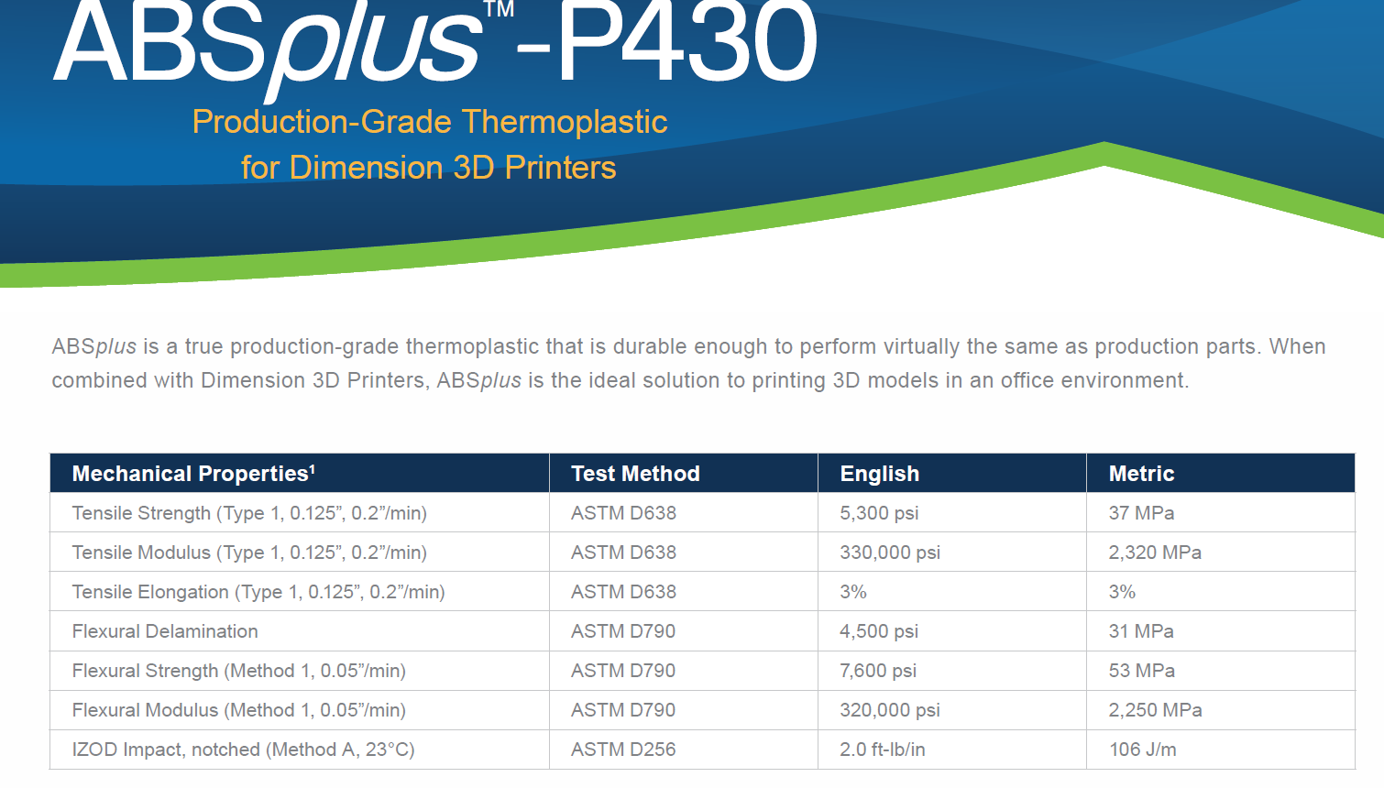

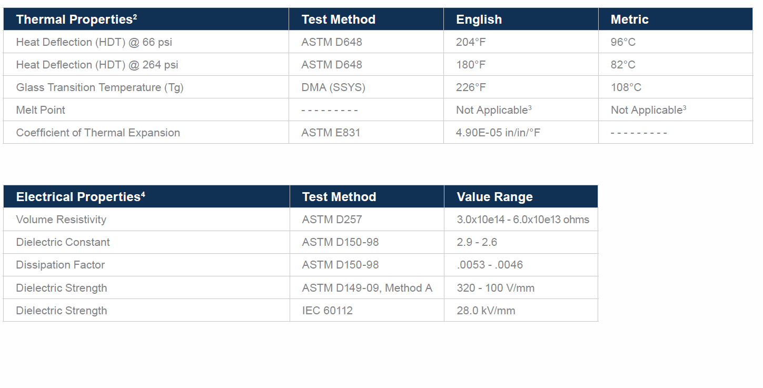

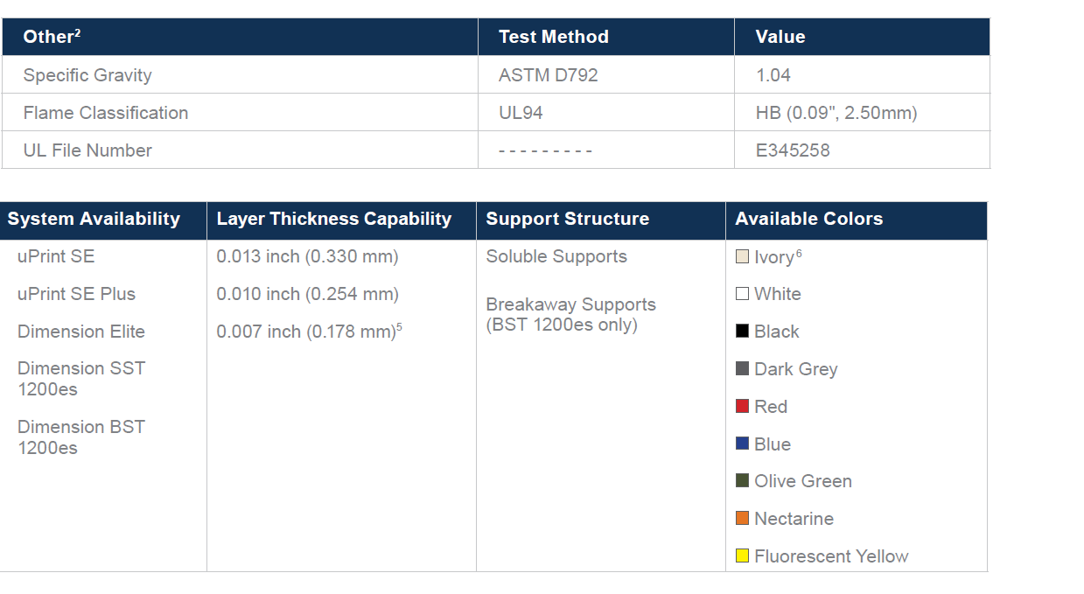

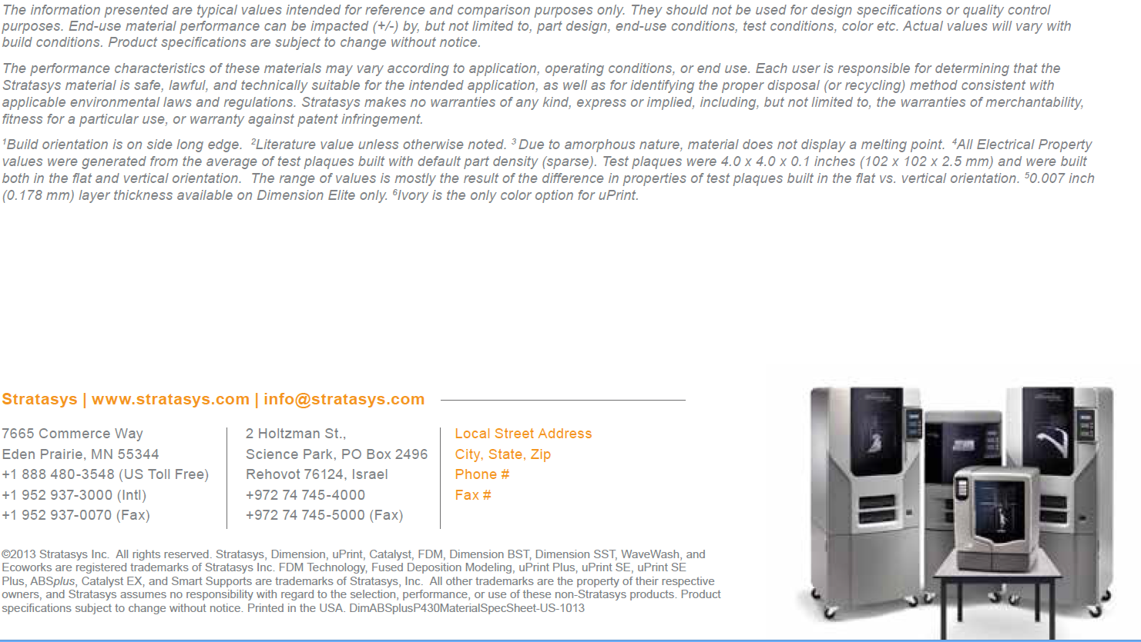

Page 1/7

Material Safety Data Sheet

acc. to ISO/DIS 11014

Printing date 01/07/2013 Reviewed on 01/07/2013

34.2.6

1

Identification of the substance/mixture and of the company/undertaking

Product identifier

Trade name: P430 ABS Model / M30 ABS Model

Application of the substance / the preparation

Filament for Stratasys® Inc. FDM™ modeler

Details of the supplier of the safety data sheet

Manufacturer/Supplier:

Stratasys, Inc. Tel +1 952 937 3000

7665 Commerce Way

Fax +1 952 937 0070

Eden Prairie, MN 55344

USA

In Europe:

C.S.B. GmbH

Tel.: +49-2151-6520860

Parkstraße 29

Fax: +49-2151-6520869

D-47829 Krefeld

E-Mail: info@csb-online.de

Germany

Information department:

Product safety department.

Emergency telephone number:

see above

2

Composition/information on ingredients

Chemical characterization: Mixtures

Description:

Thermoplastic polymer

Dangerous components:

Void

Other components:

9010-94-0 Butadiene-styrene-acrylonitrile-methyl methacrylate copolymer

70-75%

9003-54-7 Styrene/acrylonitrile copolymer (SAN)

25-30%

3

Hazards identification

Classification of the substance or mixture

The product is not classified according to

the Globally Harmonized System (GHS).

Classification according to Dir

ective 67/548/EEC or Directive 1999/45/EC

Void

Information concerning particular

hazards for human and environment:

Heightened danger of s

lipping when the product is spilled on the floor.

Classification system:

The product does not have to be labelled due to the calculation procedure of the "General Classification guideline for preparations of the EU" in the latest valid version.

Label elements

GHS label elements

Hazard pictograms

Signal word

Hazard statements

Void

Classification system

NFPA ratings (scale 0-4)

Health = 0

Fire = 0

Reactivity = 0

(Contd. on page 2)

USA

209330-0001 (B)

Page 2/7

Material Safety Data Sheet

acc. to ISO/DIS 11014

Printing date 01/07/2013

Reviewed on 01/07/2013

Trade name: P

430 ABS Model / M30 ABS Model

(Contd. of page 1)

HMIS

Health = 0

Fire = 0

Reactivity = 0

4

First aid measures

General information

Remove contaminated clothing.

After inhalation

Supply fresh air; consult doctor in case of complaints.

If dust or other particles are generated during processing, it is necessary to provide adequate ventilation and/or respiration protection. If dust/particles have been inhaled call physician.

After skin contact

Wash with soap and water.

After contact with the molten product, cool rapidly with cold water.

Do not pull solidified product away from the skin.

Call a doctor immediately.

After eye contact

Rinse opened eye for several minutes under running water. If symptoms persist, consult a doctor.

After swallowing

Rinse out mouth and then drink plenty of water.

If symptoms persist consult doctor.

5

Firefighting measures

Suitable extinguishing agents

Water spray

Foam

Alcohol resistant foam

For safety reasons unsuitable extinguishing agents

Carbon dioxide

Extinguishing powder.

Lack of cooling capacity may permit re-ignition.

Special hazards arising from the substance or mixture

In case of fire, the following can be released:

Smoke

Carbon monoxide and carbon dioxide

Hydrocarbons

Hydrogen cyanide (HCN)

In certain fire conditions, traces of other toxic gasescannot be excluded.

Protective equipment:

Wear self-contained respiratory protective device.

Additional information

Dispose of fire debris and contaminated fire fighting water in accordance with official regulations.

6

Accidental release measures

Personal precautions, protective equipment and emergency procedures

Wear protective clothing.

Avoid formation of dust.

Do not breathe dust.

Avoid contact with eyes.

Do not breathe vapors.

Particular danger of slipping on leaked/spilled product.

(Contd. on page 3)

USA

209330-0001 (B)

Page 3/7

Material Safety Data Sheet

acc. to ISO/DIS 11014

Printing date 01/07/2013

Reviewed on 01/07/2013

Trade name: P

430 ABS Model / M30 ABS Model

(Contd. of page 2)

34.2.6

Environmental precautions:

Do not allow to enter sewers/ surface or ground water.

Methods and material for containment and cleaning up:

Pick up mechanically.

Allow to solidify. Pick up mechanically.

Dispose of the collected material according to regulations.

Reference to other sections

See Section 8 for information on personal protection equipment.

See Section 13 for disposal information.

7

Handling and storage

Precautions for safe handling

Ensure good ventilation/exhaustion at the workplace.

Prevent formation of dust.

If dust/smoke is developed, avoid breathing dust/smoke.

Avoid contact with eyes.

Avoid long or repeated skin contact.

Avoid contact with hot product.

Make sure that all applicable workplace limits are observed.

Information about protection against explosions and fires:

Dust can combine with air to form an explosive mixture.

Keep ignition sources away - Do not smoke.

Protect against electrostatic charges.

Storage

Requirements to be met by storerooms and receptacles:

Observe all local and national regulations for storage of water polluting products.

Information about storage in one common storage facility:

Not required.

Further information about storage conditions:

Store in cool, dry conditions in well sealed receptacles.

Specific end use(s)

No further relevant information available.

8

Exposure controls/personal protection

Additional information about de

sign of technical systems:

No further data; see item 7.

Components with limit values that require monitoring at the workplace:

Observe all workplace limits for dust:

TLV inhalable dust: 15 mg/m³ OSHA

TLV respirable dust: 5 mg/m³ OSHA

Additional information:

The lists that were valid during the creation were used as basis.

Personal protective equipment

General protective and hygienic measures

Do not inhale dust / smoke / mist.

Avoid contact with the eyes.

Avoid close or long term contact with the skin.

Avoid skin contact with the liquefied material.

Wash hands before breaks and at the end of work.

Breathing equipment:

If all workplace limits are observed and good ventilation is ensured, no special precautions necessary.

Protection of hands:

No chemical-protective gloves required.

Use heat resistant gloves when handling hot/molten product.

Eye protection:

Safety glasses

Body protection:

Protective work clothing.

(Contd. on page 4)

USA

209330-0001 (B)

Page 4/7

Material Safety Data Sheet

acc. to ISO/DIS 11014

Printing date 01/07/2013

Reviewed on 01/07/2013

Trade name: P

430 ABS Model / M30 ABS Model

(Contd. of page 3)

34.2.6

Wear heat-resistant protective clothing when handling hot/molten product.

9

Physical and chemical properties

General Information

Appearance:

Form: solid

Color: milky white

Odor: Nearly odorless

Odor threshold: no data available

pH-value: Not applicable

Change in condition

Melting point/Melting range:

Not applicable

Boiling point/Boiling range:

Not applicable

Flash point:

Not applicable

Auto igniting:

Product is not self-igniting.

Danger of explosion:

Product does not present an explosion hazard.

Risk of dust explosion if enriched with fine dust in the presence of air

Explosion limits:

Lower:

Not determined

Upper:

Not determined

Oxidizing properties

Not applicable

Vapor pressure:

Not determined

Density at 20°C (68 °F):

> 1 g/cm³ (> 8.345 lbs/gal)

Solubility in / Miscibility with

Water:

Insoluble

Segregation coefficient (n-octonol/water):

Not applicable

Viscosity:

dynamic:

Not applicable

kinematic:

Not applicable

Other information

No further relevant information available.

10 Stability and reactivity

Thermal decomposition / conditions to be avoided:

No decomposition if used and storedaccording to specifications.

Avoid impact, friction, heat, sparks, electrostatic charges.

Incompatible materials:

No further relevant information available.

Hazardous decomposition products:

Carbon monoxide and carbon dioxide

Hydrogen cyanide (prussic acid)

Hydrocarbons

Possible in traces.

Styrene Acrylonitril Phenol Acetophenone

(Contd. on page 5)

USA

209330-0001 (B)

Page 5/7

Material Safety Data Sheet

acc. to ISO/DIS 11014

Printing date 01/07/2013 Reviewed on 01/07/2013

Trade name: P

430 ABS Model / M30 ABS Model

(Contd. of page 4)

34.2.6

Acrylmonomeres, Acrylcompounds

11 Toxicological information

Acute toxicity:

LD/LC50 values that are relevant for classification:

Oral LD50 > 5000 mg/kg (rat)

Dermal LD50 > 2000 mg/kg (rabbit)

Primary irritant effect:

on the skin:

Dust particles may mechanically irritate the skin.

· on the eye:

Dust particles may mechanically irritate the eye.

Sensitization:

No sensitizing effects known.

Additional toxicological information:

When used and handled according to specifications, the product does not have any harmful effects accordingto our experience and the information provided to us.

Carcinogenic categories

IARC (International Agency for Research on Cancer)

9003-54-7 Styrene/acrylonitrile copolymer (SAN)

3

NTP (National Toxicology Program)

None of the ingredients is listed.

12 Ecological information

Aquatic toxicity:

No further relevant information available.

Persistence and degradability

No further relevant information available.

Bioaccumulative potential

No further relevant information available.

Additional ecological information:

General notes:

Water hazard class 1 (Self-assessment) (German regulation): slightly hazardous for water.

13 Disposal considerations

Waste treatment methods

Recommendation

Must not be disposed of together with household garbage. Do not allow product to reach sewage system.

Disposal must be made according to local/official regulations.

Uncleaned packagings:

Recommendation:

Disposal must be made according to local/official regulations.

14 Transport information

UN-Number

DOT, ADR, ADN, IMDG, IATA

Void

UN proper shipping name

DOT, ADN, IMDG, IATA

Void

ADR

Void

(Contd. on page 6)

USA

209330-0001 (B)

Page 6/7

Material Safety Data Sheet

acc. to ISO/DIS 11014

Printing date 01/07/2013

Reviewed on 01/07/2013

Trade name: P430 ABS Model / M30 ABS Model

Transport hazard class(es)

DOT, ADR, ADN, IMDG, IATA

Class

Packing group

DOT, ADR, IMDG, IATA

Special precautions for user

Not applicable.

Transport in bulk according to Annex II of

MARPOL73/78 and the IBC Code

Not applicable.

Transport/Additional information:

Not dangerous according to the above specifications.

UN "Model Regulation":

15 Regulatory information

TSCA (Toxic Substances Control Act)

All ingredients are listed.

Cancerogenity categories

MAK (German Maximum Workplace Concentration)

None of the ingredients is listed.

GHS label elements

Hazard pictogram

Signal word

Hazard statements

National regulations

Water hazard class:

Water hazard class 1 (Self-assessment) (German regulation): slightly hazardous for water.

Other regulations, limitations and prohibitive regulations

The monomer compounds of this product are listed in:

Toxic Substance Control Act TSCA (USA)

Canadian Domestic Substance List DSL

Existing and New Chemical Substance List ENCS (Japan)

Australian Inventory of Chemical Substances AICS (Australia)

Korean Existing Chemical Inventory KECI

16 Other information

This information is based on our present knowledge

. However, this shall not constitute a guarantee for anyspecific product features and shall not establish a legally valid contractual relationship.

Department issuing MSDS:

C.S.B. GmbH Phone: +49 - 2151 - 652086-0

Parkstraße 29 Fax: +49 - 2151 - 652086-9

D-47829 Krefeld Germany

·Abbreviations and acronyms:

ADR: Accord européen sur le transport des marchandises dangereuses par Route (European Agreement concerning the International

Carriage of Dangerous Goods by Road)

IMDG: International Maritime Code for Dangerous Goods

DOT: US Department of Transportation

IATA: International Air Transport Association

USA 209330-0001 (B)

**VIII. FIRE FIGHTING MEASURES**

**AUTOIGNITION TEMPERATURE:** N/A

**HAZARDOUS PRODUCTS OF COMBUSTION:** Carbon dioxide, carbon monoxide and aldehydes

**EXTINGUISHING MEDIA:** Water, Foam, Carbon Dioxide, Dry Chemical

**SPECIAL FIRE FIGHTING INSTRUCTIONS/PRECAUTIONS:**

Soak thoroughly with water to cool and prevent re-ignition. The smoke can contain polymer fragments of varying composition, in addition to unidentified toxic and /or irritating compounds.

**IX. ACCIDENTAL RELEASE MEASURES**

**SPILL OR RELEASE**: Sweep up for disposal or reuse

**X. HANDLING AND STORAGE**

**HANDLING:** Wash with soap and water

**STORAGE:** Store in a sprinkler protected warehouse. If a heat source is present keep the area well ventilated

**XI. DISPOSAL CONSIDERATIONS**

**DISPOSAL:** Incineration or landfill – dispose of in accordance with Federal, State, Provincial and Local regulations.

**XII. DISCLAIMER OF EXPRESSED AND IMPLIED WARRANTIES**

The information presented in the Material Safety Data Sheet is based on data believed to be accurate as of the date this Material Safety Data Sheet was prepared. HOWEVER, NO WARRANTY OF MERCHANTABILITY, FITNESS FOR ANY PARTICULAR PURPOSE, OR ANY OTHER WARRANTY IS EXPRESSED OR IS TO BE IMPLIED REGARDING THE ACCURACY OR COMPLETENESS OF THE INFORMATION PROVIDED ABOVE, THE RESULTS TO BE OBTAINED FROM THE USE OF THIS INFORMATION OR THE PRODUCT, THE SAFETY OF THIS PRODUCT, OR THE HAZARDS RELATED TO ITS USE. No responsibility is assumed for any damage or injury resulting from abnormal use or from any failure to adhere to recommended practices. The information provided above, and the product, are furnished on the condition that the person receiving them shall make their own determination as to the suitability of the product for their particular purpose and on the condition that they assume the risk of their use. In addition, no authorization is given nor implied to practice any patented invention without a license.

**Material Safety Data Sheet**

MSDS Number: Date Prepared: 02-Oct-01

KESTER SOLDER

245 Core

Page: 1 of 6

**SECTION 1 - CHEMICAL PRODUCT AND COMPANY INFORMATION**

Product Identifier As Used On Label:

Product Use:

Manufacturer's Name and Address

**KESTER SOLDER**

**DIVISION OF LITTON SYSTEMS, INC.**

**515 E. TOUHY AVENUE**

**DES PLAINES, IL 60018 USA**

Supplier's Name and Address (if different from manufacturer)

Telephone Number For Information: (847) 297-1600 CHEMTREC 24-Hour Emergency Telephone Number: (800) 424-9300

*NA = Not Applicable NE = Not Established UN = Unknown*

**SECTION 2 - COMPOSITION / INFORMATION ON INGREDIENTS**

HAZARDOUS INGREDIENTS 1 % or greater

CARCINOGENS 0.1 % or greater

C.A.S.

Number

Weight

Percent

OSHA

PEL

ACGIH TLV LD 50

ingested

g / Kg

LC 50

inhaled

g / m³

NON-HAZARDOUS INGREDIENTS

NOTES: * See Section 15 for U.S.A. Regulatory Information.

**"245" ROSIN FLUX CORED SOLDER - LEAD ALLOY**

Soldering flux in cored solder for electrical or electronic applications.

7439-92-1 *

7440-31-5

7440-22-4 *

7440-69-9

7440-36-0 *

65997-05-9

68603-86-1

** Composition and weight % of solder alloys varies widely and can be determined by product label. Flux in core is

typically 1-3% by weight.

Lead

Tin

Silver

Bismuth

Antimony

Modified Rosin

Carboxylic Acids

0.05

2

0.01

NE

0.5

NE

NE

0.15

2

0.1

NE

0.5

7.0 Rat

< 1

< 1

mg/m³ mg/m³

TWA

OSHA: Occupational Safety and Health Administration

PEL: Permissible Exposure Limit

ACGIH: American Conference of Government Industrial Hygienists

TLV: Threshold Limit Values

STEL: Short-Term Exposure Limit

TWA: Time Weighted Average

C.A.S. Chemical Abstract Service

Form Number: 1F-RD-G-02-01B

MSDS Number: Date Prepared: 02-Oct-01

KESTER SOLDER

245 Core

Page: 2 of 6

**SECTION 3 - HAZARDS IDENTIFICATION**

*EMERGENCY OVERVIEW*

R-PHRASES (Risks to Humans or the Environment):

R 61 - May cause harm to the unborn child.

PRIMARY EXPOSURE:

Fumes during soldering may contain droplets of rosin and/or other organic decomposition products. Skin contact from handling and decomposition products when heating with soldering iron.

PRIMARY ROUTES OF ENTRY: Skin Eyes Inhalation Ingestion

TARGET ORGANS:

Flux fumes: eyes, mucous membranes and respiratory system. Ingestion of lead metal can affect kidneys, gastrointestinal, reproductive and neurological systems.

POTENTIAL HEALTH EFFECTS OF ACUTE (severe short-term) EXPOSURE:

INHALATION: Flux fumes during soldering may cause irritation and damage of mucous membranes and respiratory system.

EYE CONTACT: Irritation from contact with smoke from soldering.

SKIN CONTACT: Possible local irritation by contact with flux or fumes.

INGESTION: May be harmful if swallowed.

SKIN ABSORPTION: None.

POTENTIAL HEALTH EFFECTS OF CHRONIC (prolonged) EXPOSURE:

Smoke during soldering will contain rosin which is an allergen that can cause eye irritation and respiratory system irritation and damage. Repeated inhalation or ingestion of lead can result in systemic poisoning.

Medical Conditions Generally Aggravated by Exposure:

Chemical hypersensitivity, asthma and other respiratory conditions, existing eye and skin disorders. Lead: Diseases of the blood and blood-forming organs, kidneys, nerves and possibly reproductive systems.

CARCINOGENICITY/

TERATOGENICITY / MUTAGENICITY: See Sections 11 and 15 for additional information.

NTP OSHA IARC Not Listed

ECC (Europe) DANGEROUS SUBSTANCES

HAZARD DESIGNATION:

Hot solder can burn eyes and skin. Fumes during soldering are irritating to eyes and may cause

headache and respiratory system irritation or damage. Prolonged or repeated exposure to rosin

flux fumes during soldering may result in allergic reaction in a sensitive person, resulting in

asthma symptoms.

Xn Harmful R 62 - Possible risk of impaired fertility.

G R 33 - Danger of cumulative effects. R 36/37/38 - Irritating to eyes, respiratory system and skin.

Form Number: 1F-RD-G-02-01B

MSDS Number: Date Prepared: 02-Oct-01

KESTER SOLDER

245 Core

Page: 3 of 6

**SECTION 4 - FIRST AID MEASURES**

**Seek medical assistance for further treatment, observation and support if needed.**

EYE CONTACT: For burns flush immediately with cool water and get medical attention. For fume irritation use eye drops and remove from exposure.

SKIN CONTACT: For burns flush immediately with cool water. If a rash develops from flux fumes, remove person from exposure and wash skin with soap and water.

INHALATION: Remove person from exposure to fumes.

INGESTION: Not likely to occur.

**SECTION 5 - FIRE FIGHTING MEASURES**

Flammability: Conditions to avoid:

Flash Point (T.O.C): Auto-Ignition Temperature:

Flammability Limits percent by volume in air: LEL: UEL:

Extinguishing Means: Water Carbon Dioxide Alcohol Foam Dry Chemical

Hazardous Combustion Products:

Explosion Sensitivity: Impact - None Identified Static Discharge Sensitivity:

Special Firefighting Procedures:

Unusual Fire and Explosion Hazards:

NA

°F °C °F °C

NA

Carbon monoxide, carbon dioxide. Melted solder above 1000 °F will liberate toxic lead

and/or antimony fumes.

Avoid breathing smoke. Wear self-contained breathing apparatus if this material is in the

vicinity of a fire.

Flux in cored solder may ignite when the solder melts in a fire.

NA NA NA NA

NE

Yes No

No Yes

**SECTION 6 - ACCIDENTAL RELEASE MEASURES**

**SECTION 7 - HANDLING AND STORAGE**

Storage Precautions: Exposure to sulfur or to high humidity will tarnish the solder surface.

Handling Precautions: Do not place flux-cored solder into a hot solder pot because the flux may ignite.

Personal Precautions: Avoid breathing smoke / fumes generated during soldering. Wash hands after handling solder before eating or smoking.

Steps to be Taken if Material is Spilled or Released:

Melted solder will solidify on cooling and can be scraped up. Use caution to avoid breathing fumes if a gas torch is used to cut up large pieces.

Form Number: 1F-RD-G-02-01B

MSDS Number: Date Prepared: 02-Oct-01

KESTER SOLDER

245 Core

Page: 4 of 6

**SECTION 8 - EXPOSURE CONTROLS, PERSONAL PROTECTION**

**SECTION 9 - PHYSICAL AND CHEMICAL PROPERTIES**

**SECTION 10 - STABILITY AND REACTIVITY**

VENTILATION

TO BE USED:

Provide adequate exhaust ventilation (general and / or local) if necessary to meet exposure requirements.

Local exhaust ventilation is preferred to minimize dispersion of smoke and fumes into the work area.

Safety glasses or goggles should be used.

Respiratory Protection:

Protective Gloves: Eye Protection:

Other Protective Clothing and Equipment:

Hygienic Work Practices:

When ventilation is not sufficient to remove fumes from the breathing zone, a safety approved respirator

or self-contained breathing apparatus should be worn.

Wear rubber or cloth gloves to avoid skin contact.

None.

Wash hands thoroughly after handling chemicals or solder containing lead before eating or smoking.

Physical State at 20 °C:

Boiling Point (760 mm Hg):

Vapor Pressure (mm Hg at 20 °C):

Vapor Density (air = 1):

Solubility in Water (% by weight):

pH:

Freezing Point (760 mm Hg):

Coefficient of Water / Oil Distribution:

Appearance and Odor:

Specific Gravity (water = 1 at 25 °C):

Melting Point:

Evaporation Rate (butyl acetate = 1):

Percent Volatile (by volume):

Volatile Organic Compound (VOC):

Odor Threshold:

Solid

NA

ND

0

NA

Silver-gray metal in wire, ribbon or preformed shapes with a core of flux, no odor.

°F NA°C

>7

>212

NA

0

NA

NE

NE

°F >100°C

NA

NA °F NA °C

g / Liter

%

Chemical Stability: Conditions to avoid:

Incompatibility (materials to avoid):

Hazardous Decomposition Products:

HAZARDOUS POLYMERIZATION:

Conditions to avoid:

NE

Strong acid, strong oxidizers

When heated to soldering temperatures, the rosin may be thermally degraded to liberate aliphatic aldehydes, acids and terpenes. No lead or antimony are detected in fumes from soldering below 1000 °F (537 °C).

May Occur Not applicable.

Will Not Occur

Stable Unstable

Form Number: 1F-RD-G-02-01B

MSDS Number: Date Prepared: 02-Oct-01

KESTER SOLDER

245 Core

Page: 5 of 6

**SECTION 11 - TOXICOLOGICAL INFORMATION**

**SECTION 12 - ECOLOGICAL INFORMATION**

**SECTION 13 - DISPOSAL CONSIDERATIONS**

**SECTION 14 - TRANSPORT INFORMATION**

Waste Disposal Methods:

Empty containers may contain product residue. Observe all label precautions.

Solder can be reclaimed.

CAUTION:

DOT (U.S.A.):

TDG (Canada):

Not Regulated

Not Regulated

EXPOSURE LIMITS: Not determined for the product. See Section 2 for ingredients.

Lead can accumulate in bone and body organs, and elimination from the body is slow. Medical examinations are advised for persons repeatedly exposed to levels above the exposure limit for lead. Lead is classified as a Group 2B carcinogen by the International Agency for Research on Cancer (IARC) and the U.S. Environmental Protection Agency (EPA). Women of childbearing age should avoid chronic exposure to lead because of possible effects on reproduction and potential injury to a developing fetus.

Keep out of waterways.

Form Number: 1F-RD-G-02-01B

MSDS Number: Date Prepared: 02-Oct-01

KESTER SOLDER

245 Core

Page: 6 of 6

**SECTION 15 - REGULATORY INFORMATION**

**SECTION 16 - OTHER INFORMATION**

**U.S.A.:**

**Canada:**

**Europe:**

All Chemical substances in this product are listed in the EPA (Environmental Protection Agency) TSCA

(Toxic Substances Control Act) Inventory.

California Proposition 65:

WHMIS (Workplace Hazardous Materials Information System) CLASSIFICATION:

This product has been classified in accordance with the hazard criteria of the Canadian Controlled

Product Regulations (CPR) and the MSDS contains all the information required by the CPR.

European Council Directive 67/548/EEC

• DANGEROUS SUBSTANCES HAZARD CLASSIFICATION:

• R-PHRASES (Risks to Humans or the Environment)

• S-PHRASES (Safety Precautions for Storing, Handling and Using the Product)

D2A

NFPA Rating:

HMIS Rating:

Health: Flammability: Reactivity: Special:

Health: Flammability: Reactivity: Personal Protection:

1 1

1 1

0

0 X

Prepared By:

Telephone Number: (847) 297-1600

Date Prepared:

Supersedes:

The information contained herein is based on data considered accurate and is offered solely for information, consideration and investigation.

Kester Solder extends no warranties, makes no representations and assumes no responsibility as to the accuracy, completeness or suitability of this data for any purchaser's use. The Data on this Material Safety Data Sheet relates only to this product and does not relate to use with any other material or in any process. All chemical products should be used only by or under the direction of technically qualified personnel who are aware of the hazards involved and the necessity for reasonable care in handling. Hazard communication regulations require that employees must be trained how to use a Material Safety Data Sheet as a source for Hazard information.

D. Bernier 02-Oct-01

11-Jul-00

**PREPARATION INFORMATION**

**Revision Summary:**

R 61 - May cause harm to the unborn child.

This product contains chemicals known to the State of California to cause cancer and birth defects or other reproductive harm.

T - Toxic Xn - Harmful

S 2 - Keep out of reach of children.

S 20/21 - When using do not eat, drink or smoke.

S 23 - Do not breathe the fumes.

R 62 - Possible risk of impaired fertility.

R 33 - Danger of cumulative effects.

Change of format and new data in most sections.

USEPA - Lead and its compounds are placed in Class B2, probably carcinogenic to humans.

IARC - Lead and its compounds are placed in Class 2B, possibly carcinogenic to humans.

*This chemical is subject to the reporting requirements of Section 313 of Title III of the USA Superfund

Amendment and Reauthorization Act (SARA) of 1986 and 40 CFR, Part 372.

R 36/37/38 - Irritating to eyes, respiratory system and skin.

Form Number: 1F-RD-G-02-01B

***EXPERIMENT PROCEDURES DOCUMENTATION*** *This section is to include procedures for all aspects of the experiment from shipping to KSC to unloading and return to Houston.  Please be specific about all procedures, especially those procedures that need to take place while on the Space Station.   If there are not specific aspects to consider then please put N/A*

*A.     Equipment shipment to KSC-*

Cold stowage protocol

*B.     Ground Operations while at KSC*

Cold stowage protocol

*C.     Loading/Stowing*

Destow

Plug into one of the NanoRacks Frame-1 or 2 Module ports as soon after destowing as possible.

Power up the Frame

*D.     Pre-Flight*

Keep the Nanolab module 46 ~~Ardulab~~ cold- Cold stowage protocol.

*E.      Ascent (Launch)*

Keep in the launch axis orientation shown below with the NESI + board end on top ~~as marked on the container with the USB connection on the right side when facing the Ardulab.~~



*F.      On-Orbit-*

The payload is automated; it will utilize the standard NanoRacks Platform plug-n-play operations for power and data.

Operate for minimum 24 ~~30~~ days (+/- week)*

Downlink data once on the 24th day. ~~29~~~~th~~ ~~day ( or 3 times a week if the real time clock is used)~~

*NOTE: This payload can be left in the active Frame and executed as long as needed until standard time to pack for return (i.e. no hard constraint for deactivation time).

*G.     Descent (Return/landing)*

Destow from NanoRacks Platform Frame to pack for return to Earth on Space X8 ~~X5~~

*H.     Post-Flight*

Return to Duchesne Academy in Houston, TX

*I.        Off-Loading*

Please return in the same orientation as transport to ISS. Keep in the launch axis orientation as shown below with the NESI + board end on top ~~Orient the Ardulab with the Arduino Mega board on the back wall and the USB connection pointing to the right~~.



*J.       Emergency/Contingency*

Contact Kathy Duquesnay *713-419-7670 or* [*kathy.duquesnay@duchesne.org*](mailto:kathy.duquesnay@duchesne.org)

***BIBLIOGRAPHY***

*Barker, Allen. “Laboratory Manual: Experiment 11.” University of Massachusetts.Web.3*

*Oct.2013*

*Cobb, Bruce. "Golden Sweet Pea Tendrils and Corn Shoots.” Web. 2 Oct. 2013.*

*"Easy breakfast (with shoots!)." (2012)Web. 2 Oct. 2013.*

*Herridge, Linda. “LED Lights Used in Plant Growth Experiments for Deep Space Missions.”*

*NASA's John F. Kennedy Space Center: 1. NASA. Web. 26 September. 2013.*

*"How to Grow Pea Shoots Quickly and Cheaply." (2013): Web. 2 Oct. 2013.*

*James Owen. “Plants Grow Fine Without Gravity” National Geographic News. Web. 2 October*

*2013*

*Jones, Farmer Lee. "Popcorn Shoots."  Popcorn Shoots. 2013. Web. 2 Oct. 2013.*

*"The nutritional benefits of eating bamboo shoots." Web. 2 Oct. 2013.*

*“Plants in Space” Nasa. Web. 1 October 2013*

*“Wavelengths for the various colors.” Web.3 Oct.2013.*

*Wells, Robert. “Plants in Space: No Gravity Required.” Futurity. Web.  2 October 2013*

*“Why Study Plants?” Nasa. Web. October 1 2013*

***DEVIATIONS/EXCEPTIONS/WAIVERS***

*Include any waivers or exceptions documentation from CASIS, NanoRacks, or NASA JSC if applicable*

None