What temperature do you need?   +4 degrees C Refrigerator temp? yes

Not Frozen?  No

Does it need to be cold right at hand over, stay cold during launch? Yes

Can it be destowed cold, then plugged in right away? Yes   Wait time? No

What about after experiment is complete? Yes + 4 degrees C Does it need to be cold until its return on Space X 5 ( a month later)?  Yes if at possible to preserve hinder any additional growth

Does the experiment need to be set by an agent? No

Are there any special orientation requests during launch? Yes

The lights need to be oriented towards the top of the ardulab and the seed containers should be at the bottom see the orientation in the diagram

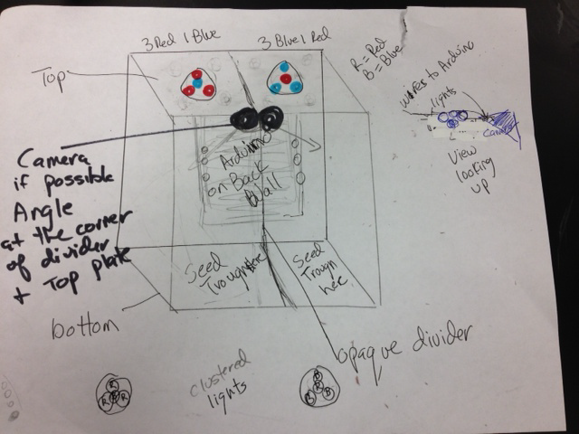



What is the temperature for loss of science? 35 degrees Celsius

Minimum temp allowed? + 4 degrees C Max temp allowed? 30 degrees Celsius

Approximate weight of your total experiment? 800 g

Shelf life for the samples being launched? 45 days if kept at +4 degrees Celsius

Back-up plan protocol

We would provide 2 additional seed troughs containing Phytoblend agar and seeds in a separate container. If the flight is delayed more than 45 days the Ardulab

Someone would to:

1 carefully pry open the bottom side of the Ardulab,

2 remove 2 seed troughs (one from each side),

3 evenly distribute the new seeds into the replacement seed troughs containing new photoblend agar

4 attach the new seed troughs on the bottom side of the Ardulab

5 snap the bottom back in place

The principle investigator, Kathy Duquesnay, plans to be at the May 1st launch of Orb 2. If the flight is delayed or scrubbed she will explain the above procedure in person.

