Practicum 11-S Slime Mold Plating

Goal: To gain skills in biological specimen handling and sterile technique. And to produce viable cultures of slime mold for future use. And to gather the necessary data for our experiment.
Rules:
- Learn about sterile technique.
- Use a Bunsen burner and glass rod to make a petri spreader.
- Learn how to pour agar plates.
- Learn how to streak agar plates and isolate cultures.
- Analyze our cultures by visual classification.
- Make as many sub-cultures as we can.
- Begin tracking our cultures via photo.
- Begin timing our slime mold growth pattern to establish the
experimental parameters for the ISS experiment.
- Begin timing the response time to new food sites.
- Force sporulation and time the response.
Thoughts:
- How many types of slime mold do we want?
- How many timing events are necessary for good data?
- What happens if the slime molds die?
- How liable to infection are slime molds?
- How will we keep the slime molds in stasis for 2 weeks?
- What will we feed them?

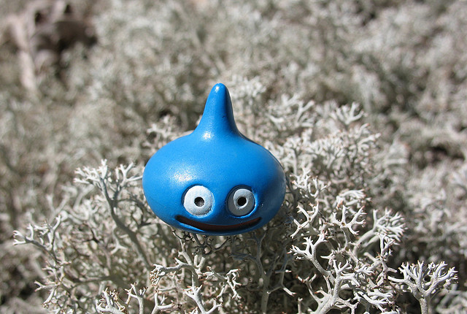

The elusive happy-blue-drop slime mold.

