Practicum 12-S Slime Mold Time-elapsed Filming

Goal: To design and build a habitat in which our slime molds can grow under the careful watch of an Arduino-based camera system.
Rules:
- Discuss the design.
- Draw sketches of the designs you want.
- Take a picture of each sketch and email it to me.
- Find an Arduino code that will allow us to use our camera.
- Analyze the code to see what modifications we need to make.
- Email me the modified code.
- Draw a circuit schematic that shows all components.
- Build device necessary for camera and lighting.
- Build circuit necessary for photography.
- Upload and run the Arduino program to run camera and collect data.
Thoughts:
- How many different cultures do you want to monitor?
- How frequently should we take a picture?
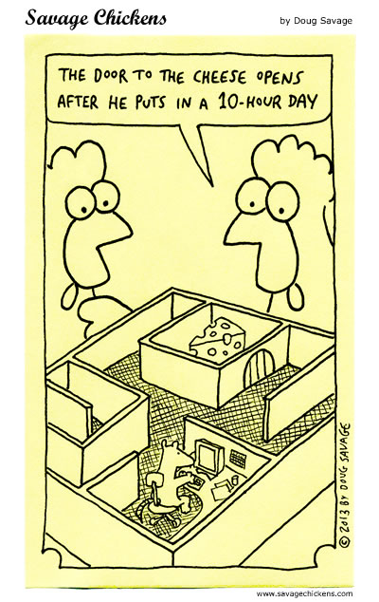
- How will be provide light for the picture?
- How much light do we need to provide?
- Where will we collect the picture data?
- What will we feed them?

